

National University of Computer and Emerging Sciences



Panda Mall

Asjad Iftikhar……….…18L-0951

Muhammad Zain ……….…18L-1109

Tayyab Waseem……….…18L-1017

Supervisor:Mr. Razi-uddin

B.S. Computer Science

Final Year Project

December 2021

Anti-Plagiarism Declaration

This is to declare that the above publication produced under the:

**Title: ____Panda Mall___________________________________________________** is the sole contribution of the author(s) and no part hereof has been reproduced on **as it is** basis (cut and paste) which can be considered as Plagiarism. All referenced parts have been used to argue the idea and have been cited properly. I/We will be responsible and liable for any consequence if violation of this declaration is determined.

Date: 29th, December, 2021

Student 1

Name: Asjad Iftikhar

Signature: _______________________

Student 2

Name: Muhammad Zain

Signature: _______________________

Student 3

Name: Tayyab Waseem

Signature: _______________________

Table of Contents

List of Tables iii

List of Figures iv

Abstract 1

Chapter 1: Introduction 2

1.1 Goals and Objectives 2

1.2 Scope of the Project 2

Chapter 2: Literature Survey / Related Work 4

2.1 Functional Tensor Factorization 4

2.2 Collaborative Filtering 4

Chapter 3: Requirements and Design 5

3.1 Functional Requirements 5

3.1.1 Functional requirements for Users 5

3.1.2 Functional requirements for Administrators 5

3.1.3 Functional requirements for Stores 5

3.2 Non-Functional Requirements 6

3.2.1 Availability 6

3.2.2 Usability 6

3.2.3 Reliability 6

3.2.4 Scalability 6

3.2.5 Data Integrity 6

3.2.6 Performance 6

3.3 Hardware and Software Requirements 6

3.3.1 Hardware Requirement 6

3.3.2 Software Requirement 6

3.4 System Architecture 7

3.4.1 Front-end 7

3.4.2 Back-end 8

3.4.3 Subsystem Architecture 8

3.5 Architectural Strategies 9

3.5.1 ReactJS, Node JS, Python, Express Server, Mongo DB 9

3.5.2 Future plans for enhancing software 9

3.5.3 User interface paradigms 9

3.5.4 Error detection and recovery 10

3.5.5 Concurrency and Synchronization 10

3.5.6 Memory management policies 10

3.6 Use Cases 11

3.6.1 Login Account 11

3.6.2 Create Account 11

3.6.3 Reset Password 12

3.6.4 Logout 12

3.6.5 Edit Profile 13

3.6.6 View Product Details 13

3.6.7 Buy Product 14

3.6.8 Add to Favorites 14

3.6.9 Remove from favorites 15

3.6.10 View favorites list 15

3.6.11 Filter Product by Type 16

3.6.12 Filter Product by Size 16

3.6.13 Filter Product by Color 17

3.6.14 Filter Product by Waist 17

3.6.15 Filter Product by Price Range 18

3.6.16 Filter Product by Discount Factor 18

3.6.17 Approve Products 19

3.6.18 Suspend Product 19

3.6.19 View Product 20

3.6.20 View home page 20

3.6.21 Add product 21

3.6.22 Delete a product 21

3.6.23 Update product 22

3.6.24 Give Feedback 22

3.7 GUI 24

3.7.1 Admin panel 24

3.7.2 Store GUI 25

3.7.3 Login GUI 27

3.7.4 Sign Up GUI 27

3.7.5 User/Client Pages GUI 28

3.8 Database Design 30

3.8.1 ER Diagram 30

3.8.2 Data Dictionary 30

3.9 System Requirements 33

3.9.1 Hardware Requirements 33

3.9.2 Software Requirements 33

3.10 Design Considerations 33

3.10.1 Assumptions and Dependencies 33

3.10.2 General Constraints 33

3.11 Development Methods 34

3.12 Class diagram 35

3.13 Sequence diagram 36

3.14 Policies and Tactics 46

3.14.1 Product to use 46

3.14.2 Coding guidelines and conventions 46

3.14.3 Testing the software 46

3.14.4 Maintaining the software 46

3.14.5 Protocol 47

3.14.6 Accessing the application 47

3.14.7 Choice of algorithm 47

3.14.8 Web Scrapping 47

Chapter 4: Implementation and Test Cases 48

4.1 Implementation 48

4.1.1 Beautiful Soup 48

4.1.2 Brute Force 48

4.1.3 Collaborative Filtering 48

Chapter 5: Conclusion 49

References 50

List of Tables

Table 1: User Data Dictionary 30

Table 2: Favourites Data Dictionary 31

Table 3: Product Data Dictionary 31

Table 4: Purchase History Data Dictionary 32

Table 5: Store Data Dictionary 32

Table 6: Admin Data Dictionary 32

Table 7: Discount Factor Data Dictionary 33

List of Figures

Figure 1: High Level System Architecture 7

Figure 2: Login Screen 24

Figure 3: Manage Products 24

Figure 4: Update product page 25

Figure 5: Store home page 25

Figure 6: Pop up window 26

Figure 7: Edit product 26

Figure 8: Login page 27

Figure 9: Sign Up page 27

Figure 10: Favorite’s page 28

Figure 11: Product Details page 28

Figure 12: Home Page 29

Figure 13: Profile page 29

Figure 14: ER Diagram 30

Figure 15: Class Diagram 35

Figure 16: Login Account 36

Figure 17: Create Account/Signup 36

Figure 18: Reset/Forget Password 37

Figure 19: Logout 37

Figure 20: Edit Profile 38

Figure 21: View Product Details 38

Figure 22: Buy Product 39

Figure 23: Add/Remove favorites 39

Figure 24: View Favorites List 40

Figure 25: Filter by Type 40

Figure 26: Filter by Size 41

Figure 27: Filter by Color 41

Figure 28: Filter by Waist 42

Figure 29: Filter by Price Range 42

Figure 30: Filter by Discount Factor 43

Figure 31: Product Approval 43

Figure 32: View Product 44

Figure 33: Home Page 44

Figure 34: Add Product 45

Figure 35: Update product 45

Figure 36: Delete Product 46

Figure 37: Collaborative Filtering 48

# Abstract

Pakistan's eCommerce market grew by 90% in 2020, contributing to a global growth rate of 29%. Panda Mall is a web-based Recommendation System (RS) which recommends products from various online shopping stores in Pakistan based on customer preferences. It aims to solve the problem of choice overload [1] created as a result of hundreds of online shopping stores opening to cash in Pakistan’s eCommerce boom and to combat the lockdowns imposed in the wake of Covid-19 pandemic. The main idea is to register products available from these online shopping stores using automated scrapping and manual registration in the system and recommend to registered customers based on preferences, feedback and history. Instead of visiting multiple websites and hundreds of products, a customer can sign up and let Panda Mall do all the browsing and filtering to display a manageable number of products in a modern and elegant interface. The website developed in this project use PostgreSQL for the data storage, Python Django for backend business layer and machine learning algorithms implementation, React.JS for the front end. The fundamental idea is to enhance online shopping experience similar to how physical shopping malls enhanced the shopping experience for retail stores.

# Introduction

During the COVID-19 pandemic online apparel shopping stores, in Pakistan, have grown exponentially in number. One major challenge for customers is that at any given time there are hundreds of stores to buy from, which makes shopping a tedious task. With advancement in machine learning and data science, an obvious solution is a recommendation system which assist the buyers in decision making, similar to how Netflix [5] provides a recommendation system for its subscribers to choose the best movies.

The goal of this project is to develop an automated system that can scrape and collect data on clothing products, then optimize and analyze it using Artificial Intelligence and Data Science to make recommendations based on user preferences and purchase history.

Our primary focus will be on gathering data by registration or automatic scraping, processing the data, and displaying the recommendations in a user-friendly online interface. We will also keep track of each user's previous purchases in order to improve over time.

Data about brands and products will be obtained from:

1. Websites of brands directly.
2. Registration at Panda Mall

The results obtained from the model will be presented in a simplified web interface along with all the necessary information for customers to make a buying decision with ease.

This document primarily covers how the system works and the concepts that were employed in its development. The work done in this scope is explained in the following chapter. Furthermore, in Chapter 3, all of our system's requirements, both functional and non-functional are described, as well as the system architecture, strategies and use cases. Chapter 4 covers the implementation and operation of our system. Finally, chapter 5 explains the overview, the obstacles that were encountered, and the breakdown of future work.

## Goals and Objectives

The primary goals and objectives of this project are:

* To design a user-friendly website that helps in recommending the best clothing products for the user.
* To provide a platform where items of multiple stores will be listed for recommendation.
* To use Machine Learning (ML) models such as collaborative filtering to produce efficient and effective recommendation engine.

## Scope of the Project

The project will be implemented in three components. In first component, brands and product data will be collected from both automated web scrappers and a manual store registration process at Panda Mall website. After data analysis, it will be exported to the second component. Second component will use this data to train a machine learning model using a custom-built variation of collaborative filtering algorithm.

Third component will consist of creating a website module for the users. User can register on the website. With the account user can search a product of their interest. The items can be filtered with the various options size, color and preferred brand etc. Items displayed on the result query will filter through the options before it is fed as input to the model trained in component two, the output will contain a filtered list of the best recommended products for the particular user. After the purchase of product, users will be reminded to fill out the feedback against the purchase. This feedback will be permanently recorded for future recommendations.

# 

# Literature Survey / Related Work

## Functional Tensor Factorization

Hu et al. [2] researched on personalized clothing recommendation systems. He presented a functional tensor factorization approach to describe user-item and item-item interaction.

## Collaborative Filtering

Nogueira et al. [3] proposed a new collaborative filtering algorithm for better accuracy in clothing recommendation systems. After a lot of research, we have inclined towards collaborative filtering method for our recommendation system as we have found it more effective and accurate in these types of recommendation systems. Landia in [4] explains challenges faced during construction of fashion recommendation system. He has organized challenges into two categories namely retailer related and customer related. The prior consists of short lifetime of items and high volume of items, whereas seasonality and rapidly changing customer preferences make up some of the customer related challenges. Majority of the recommendation systems deal with products from a single clothing store unlike our system which will deal with different type of clothes from different clothing stores.

.

# Requirements and Design

## Functional Requirements

### Functional requirements for Users

* System will allow user to login by authenticating user login credentials.
* System will allow user to create a new account by providing required information.
* System will allow user to reset password via email.
* System will allow user to logout.
* System will allow user to edit profile.
* System will display clothing products based on user’s profile.
* System will allow user to filter out products based on Type.
* System will allow user to filter out products based on Sizes.
* System will allow user to filter out products based on Colors.
* System will allow user to filter out products based on Waists.
* System will allow user to filter out products based on Price Range.
* System will allow user to filter out products based on Discount factor.
* System will allow user to filter out products based on Brands.
* System will allow user to view selected product details.
* System will allow user to buy product by redirecting to respected page.
* System will allow user to add products to favorites.
* System will allow user to give feedback on the product bought.

### Functional requirements for Administrators

* Administrators can approve/reject products.
* Administrators can update products.
* Administrators can view products.

### Functional requirements for Stores

* Stores can add products.
* Stores can update products.
* Stores can view products.
* Stores can remove products.

## Non-Functional Requirements

### Availability

System will be available for the users for at-least 160 hours a week.

### Usability

System will have an intuitive design.

* Our system interface will be easy to learn and user interactive. A rookie will require at-most 5 seconds to learn the interface.

### Reliability

System will show the result of the desired filter within 3 seconds.

### Scalability

System will ensure there will be no significant performance degrade for at-most 100 users.

### Data Integrity

System will ensure user’s personal data is not tempered by unauthorized source.

### Performance

All data views are paginated to allow limited and required information to prevent long load times.

## Hardware and Software Requirements

### Hardware Requirement

* A IOT device that supports a browser.
* Internet connection should have at least 1Mbps.
* A web server to host our website.

### Software Requirement

Web browser in the system.

## System Architecture

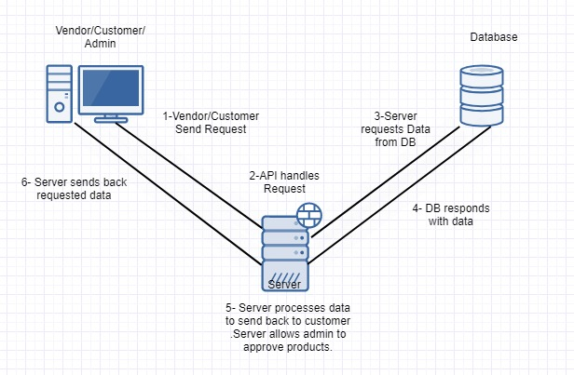

Figure 1: High Level System Architecture

This is System Architecture Diagram for our system.

As show in the diagram above we will be using 3-layer architecture for our system. Our users (Customer, Vendor and Admin) will interact with the presentation layer that will forward user requests to the server which will be acting as the business layer. It will process all the user request and send them back to the presentation layer. If needed it will interact with our cloud-based database that corresponds to the database layer to retrieve any kind of information needed.

### Front-end

Our front-end has the following components:

#### Customer

Customer is the user that logs in to our system using his account and interacts with the application to buy products. Each customer request goes from the presentation layer to the server where the request is processed and the required data is fetched from the database layer and then the result in forwarded back to the presentation layer where the results are shown to the customer. Customer can perform following requests/functions:

* Login
* Sign up
* Reset password
* Logout
* Edit Profile
* Buy product
* Add products to favorites
* Give feedback on products
* Filter products based on several filters

#### Vendor

Vendor is the user which creates a store and then adds his/her products to our website. Each vendor request goes from the presentation layer to the server where the request is processed and the given data is stored to the database layer. Vendor can perform following requests/functions

* Add products
* Update products
* View products
* Remove products

#### Admin

Admin is the user of the system which approves the newly added products. If he approved a product then the product is added to the database otherwise the product is discarded.

* Approve/Reject products
* View products

### Back-end

Our Back-end has the following components:

#### Express Server

Our server connects our database layer to the presentation layer. It processes all the requests coming from the users (presentation layer) in HTML format. After processing the request, it fetches the required information from the database layer in the form of JSON objects. After that the server responds back to the presentation layer by sending the requested information.

#### MongoDB

This is our database where all the information about system users, products is stored in JSON format. Our database is hosted on the cloud so as a result it is scalable and efficient. It assists our server by providing required information needed to respond to user requests.

### Subsystem Architecture

There is no such component in our system architecture section that merits a detailed discussion

## Architectural Strategies

### ReactJS, Node JS, Python, Express Server, Mongo DB

When it comes to machine learning there is no better option than Python. As it provides different types of libraries to manipulate and perform different functions on large amount of data. We will be using python with Jupiter Notebook.

Our system’s front end will be designed using ReactJS. It provides us with JavaScript libraries that helps us to perform our work. Major benefit of using ReactJS is its reusable components that allows us to use same components for different pages wherever needed. Moreover, ReactJS enables significant data changes that result in automatic alteration in the selected parts of user interfaces.

We will be using NodeJS with python as our backend languages. Every other aspect expects for manipulating datasets will be handled by NodeJS. The reason for using NodeJS is its compatibility with ReactJS which we will be using as our frontend.

For our server we have decided to use Express Server. As we are using JavaScript for our frontend and backend so why not using it to implement the server. Major benefit of using this server is its ability to handle several requests efficiently. Moreover, it also has a highly supportive open-source community.

For our database we will be using MongoDB because of its scalability benefits. It has a very simple design with all the data stored as a single JSON object hence making key functions like saving and loading data relatively easier.

### Future plans for enhancing software

For this project we are limiting our scope to a web application but in the future, we are planning to scale our project by:

* We are planning to implement a cart system that we will integrate with the payment procedure to help our users to buy product directly from our website.
* We plan to develop a mobile application with all the features of our web application in order to assist the user.

### User interface paradigms

While making our UI we will implement the eight golden rules of user interaction in our Software Engineering course. Following are those rules:

1. Strive for consistency.
2. Seek universal usability.
3. Offer informative feedback.
4. Design dialogs.
5. Prevent errors.
6. Permit easy reversal of actions.
7. Keep users in control.
8. Reduce short term memory load.

This will help our UI to be able to yield better performance and efficiency. It will also make our UI user friendly.

### Error detection and recovery

In our situation, the most typical error occurs during the authentication process, when a user enters incorrect credentials, which our system authenticates and, if they are invalid, displays an error message to the user.

Furthermore, if a user inputs incorrect information during registration or profile modification, our system will display an error message requiring the user to reenter the incorrect information.

If a user attempts to purchase a product that the vendor has rendered unavailable, our system will route the user to an error page informing them of the product's unavailability. Furthermore, we will update the product list once a week to ensure that users have access to the most up-to-date products.

### Concurrency and Synchronization

Hopefully a lot of users will be accessing our website and as result making lot of simultaneous requests. So, we need to make our system synchronized so that we can treat each request independently. In order to do that we have to implement threading into our business logic.

### Memory management policies

As already stated above we will be using MongoDB which in an online database running in real-time on cloud. So, in order to access that DB our system users should be connected to the internet.

## Use Cases

### Login Account

|  |  |  |  |  |
| --- | --- | --- | --- | --- |
| **Name** | | Login Account | | |
| **Actors** | | Client, Admin, Store Owner | | |
| **Summary** | | User will be able to login into account. | | |
| **Pre-Conditions** | | User should be registered in the system.  User should not already be logged in. | | |
| **Post-Conditions** | | User shall be logged in successfully. | | |
| **Special Requirements** | | None | | |
| **Basic Flow** | | | | |
| **Actor Action** | | | **System Response** | |
| 1 | User opens the login page. | | 2 | System displays Login page asking for username and password. |
| 3 | User enters valid login credentials and press login button. | | 4 | System verifies the user credentials, establishes session and redirects the user to the home page. |
| **Alternative Flow** | | | | |
| **Actor Action** | | | **System Response** | |
| 3 | User enters invalid login credentials and presses the login button. | | 4-A | System prompts the error message: *Incorrect username or password entered.* |

### Create Account

|  |  |  |  |  |
| --- | --- | --- | --- | --- |
| **Name** | | Create Account | | |
| **Actors** | | Client | | |
| **Summary** | | User will be able to create a new account by providing the required information. | | |
| **Pre-Conditions** | | User clicked on Sign-up button from the login page. | | |
| **Post-Conditions** | | User’s account shall be created successfully. | | |
| **Special Requirements** | | None | | |
| **Basic Flow** | | | | |
| **Actor Action** | | | **System Response** | |
| 1 | User clicks on the Sign-up button from the Login page. | | 2 | System displays Sign-up page asking for required information. |
| 3 | User enters valid information and presses submit button. | | 4 | System verifies the information, creates a new account and redirects the user to the login page. |
| **Alternative Flow** | | | | |
| **Actor Action** | | | **System Response** | |
| 3 | User enters invalid information and presses submit button. | | 4-A | System prompts the error message: *Incorrect/Missing required information* |

### Reset Password

|  |  |  |  |  |
| --- | --- | --- | --- | --- |
| **Name** | | Reset Password | | |
| **Actors** | | Client | | |
| **Summary** | | User will be able to reset his/her account password. | | |
| **Pre-Conditions** | | User should have an existing account.  User clicked on “Forget Password?” button from Login page. | | |
| **Post-Conditions** | | User shall receive reset password request on his/her email. | | |
| **Special Requirements** | | None | | |
| **Basic Flow** | | | | |
| **Actor Action** | | | **System Response** | |
| 1 | User clicks on the “Forget Password?” button from the Login page. | | 2 | System displays a prompt asking for user’s username. |
| 3 | User enters username and presses submit button. | | 4 | System verifies the username, sends an email to the respective user account and redirects the user to the login page. |
| **Alternative Flow** | | | | |
| **Actor Action** | | | **System Response** | |
| 3 | User enters invalid username and presses submit button. | | 4-A | System prompts the error message: *Username not found* |

### Logout

|  |  |  |  |  |
| --- | --- | --- | --- | --- |
| **Name** | | Logout | | |
| **Actors** | | Client | | |
| **Summary** | | User will be able to logout his/her account. | | |
| **Pre-Conditions** | | User should have logged in.  User clicked on “Logout” button from Home page. | | |
| **Post-Conditions** | | User shall be logged out. | | |
| **Special Requirements** | | None | | |
| **Basic Flow** | | | | |
| **Actor Action** | | | **System Response** | |
| 1 | User clicks on the “Logout?” button from the home page. | | 2 | System will logout the user and redirect the user to Login page. |
| **No Alternative Flow** | | | | |

### Edit Profile

|  |  |  |  |  |
| --- | --- | --- | --- | --- |
| **Name** | | Edit Profile | | |
| **Actors** | | Client | | |
| **Summary** | | User will be able to edit his/her profile. | | |
| **Pre-Conditions** | | User should have logged in.  User clicked on “Edit Profile” button from Home page. | | |
| **Post-Conditions** | | User’s profile shall be updated. | | |
| **Special Requirements** | | None | | |
| **Basic Flow** | | | | |
| **Actor Action** | | | **System Response** | |
| 1 | User clicks on the “Edit Profile” button from the Home page. | | 2 | System displays a new page containing user’s current information. |
| 3 | User edits his/her profile by providing valid information and presses update button. | | 4 | System validates the information, updates his/her profile and redirects the user to the Home page. |
| **Alternative Flow** | | | | |
| **Actor Action** | | | **System Response** | |
| 3 | User enters invalid profile information and presses update button. | | 4-A | System prompts the error message: *Information provided is incorrect.* |

### View Product Details

|  |  |  |  |  |
| --- | --- | --- | --- | --- |
| **Name** | | View Product Details | | |
| **Actors** | | Client | | |
| **Summary** | | User will be able to view the details of the selected product. | | |
| **Pre-Conditions** | | User should have logged in.  User should have clicked on a “Details” button. | | |
| **Post-Conditions** | | Users shall be to see the product details. | | |
| **Special Requirements** | | None | | |
| **Basic Flow** | | | | |
| **Actor Action** | | | **System Response** | |
| 1 | User clicks on the “Details” button from the Home page. | | 2 | System displays a pop-up containing product details. |
| **No Alternative Flow** | | | | |

### Buy Product

|  |  |  |  |  |
| --- | --- | --- | --- | --- |
| **Name** | | Buy a Product | | |
| **Actors** | | Client | | |
| **Summary** | | User will be able to buy a product from the respected brand’s website. | | |
| **Pre-Conditions** | | User must be logged in.  User must have clicked on “Detail” button for the selected product. | | |
| **Post-Conditions** | | System will redirect user to the respective brand website. | | |
| **Special Requirements** | | None | | |
| **Basic Flow** | | | | |
| **Actor Action** | | | **System Response** | |
| 1 | User clicks on the “Buy” button located in the product details. | | 2 | System redirects the user to the respected link of the product. |
| **No Alternative Flow** | | | | |

### Add to Favorites

|  |  |  |  |  |
| --- | --- | --- | --- | --- |
| **Name** | | Add to favorites | | |
| **Actors** | | Client | | |
| **Summary** | | User will be able to add a product to his/her favorites list. | | |
| **Pre-Conditions** | | User must be logged in.  Selected product should not be in the favorites list | | |
| **Post-Conditions** | | System will update the favorites list by adding a product. | | |
| **Special Requirements** | | None | | |
| **Basic Flow** | | | | |
| **Actor Action** | | | **System Response** | |
| 1 | User clicks on the “Favorites” icon from the selected product. | | 2 | System adds the product to his/her favorites list. |
| **No Alternative Flow** | | | | |

### Remove from favorites

|  |  |  |  |  |
| --- | --- | --- | --- | --- |
| **Name** | | Remove from favorites | | |
| **Actors** | | Client | | |
| **Summary** | | User will be able to remove a product from his/her favorites list. | | |
| **Pre-Conditions** | | User must be logged in.  Selected product should be in the favorites list | | |
| **Post-Conditions** | | System will update the favorites list by removing a product. | | |
| **Special Requirements** | | None | | |
| **Basic Flow** | | | | |
| **Actor Action** | | | **System Response** | |
| 1 | User clicks on the “Favorites” icon from the selected product. | | 2 | System will remove the product from his/her favorites list. |
| **No Alternative Flow** | | | | |

### View favorites list

|  |  |  |  |  |
| --- | --- | --- | --- | --- |
| **Name** | | View favorites list | | |
| **Actors** | | Client | | |
| **Summary** | | User will be able to view favorites list. | | |
| **Pre-Conditions** | | User must be logged in. | | |
| **Post-Conditions** | | User shall be able to view his/her favorites list. | | |
| **Special Requirements** | | None | | |
| **Basic Flow** | | | | |
| **Actor Action** | | | **System Response** | |
| 1 | User clicks on the “View favorites” button from the home page. | | 2 | System redirects the user to the new page containing a list of user’s favorite items. If there are no products in the favorites list then an empty list will be displayed. |
| **No Alternative Flow** | | | | |

### Filter Product by Type

|  |  |  |  |  |
| --- | --- | --- | --- | --- |
| **Name** | | Filter product by type | | |
| **Actors** | | Client | | |
| **Summary** | | User will be able to filter out products based on product type. | | |
| **Pre-Conditions** | | User must be logged in. | | |
| **Post-Conditions** | | User will be able to view filtered product list. | | |
| **Special Requirements** | | Reliability (filtering takes less than 3 seconds). | | |
| **Basic Flow** | | | | |
| **Actor Action** | | | **System Response** | |
| 1 | User clicks on the “Filter” button from the home page. | | 2 | System displays a dropdown menu containing different types of filters. |
| 3 | User selects the “Type” filter from the dropdown menu. | | 4 | System displays a pop-up of types for clothing products e.g. (Men’s T-Shirts, Men’s Polo Shirts, Men’s Trousers). |
| 5 | User selects a type from the pop-up window. | | 6 | System reloads the home page and displays the products based on the user’s filtering criteria. |
| **No Alternative Flow** | | | | |

### Filter Product by Size

|  |  |  |  |  |
| --- | --- | --- | --- | --- |
| **Name** | | Filter product by size | | |
| **Actors** | | Client | | |
| **Summary** | | User will be able to filter out products based on product sizes. | | |
| **Pre-Conditions** | | User must be logged in. | | |
| **Post-Conditions** | | User will be able to view filtered product list. | | |
| **Special Requirements** | | Reliability (filtering takes less than 3 seconds). | | |
| **Basic Flow** | | | | |
| **Actor Action** | | | **System Response** | |
| 1 | User clicks on the “Filter” button from the home page. | | 2 | System displays a dropdown menu containing different types of filters. |
| 3 | User selects the “Size” filter from the dropdown menu. | | 4 | System displays a pop-up of sizes for clothing products e.g. (Small, Large). |
| 5 | User selects a size from the pop-up window. | | 6 | System reloads the home page and displays the products based on the user’s filtering criteria. |
| **No Alternative Flow** | | | | |

### Filter Product by Color

|  |  |  |  |  |
| --- | --- | --- | --- | --- |
| **Name** | | Filter product by color | | |
| **Actors** | | Client | | |
| **Summary** | | User will be able to filter out products based on product color. | | |
| **Pre-Conditions** | | User must be logged in. | | |
| **Post-Conditions** | | User will be able to view filtered product list. | | |
| **Special Requirements** | | Reliability (filtering takes less than 3 seconds). | | |
| **Basic Flow** | | | | |
| **Actor Action** | | | **System Response** | |
| 1 | User clicks on the “Filter” button from the home page. | | 2 | System displays a dropdown menu containing different types of filters. |
| 3 | User selects the “Color” filter from the dropdown menu. | | 4 | System displays a pop-up of colors for clothing products e.g. (Red, Green). |
| 5 | User selects a color from the pop-up window. | | 6 | System reloads the home page and displays the products based on the user’s filtering criteria. |
| **No Alternative Flow** | | | | |

### Filter Product by Waist

|  |  |  |  |  |
| --- | --- | --- | --- | --- |
| **Name** | | Filter product by waist | | |
| **Actors** | | Client | | |
| **Summary** | | User will be able to filter out products based on product waist. | | |
| **Pre-Conditions** | | User must be logged in. | | |
| **Post-Conditions** | | User will be able to view filtered product list. | | |
| **Special Requirements** | | Reliability (filtering takes less than 3 seconds). | | |
| **Basic Flow** | | | | |
| **Actor Action** | | | **System Response** | |
| 1 | User clicks on the “Filter” button from the home page. | | 2 | System displays a dropdown menu containing different types of filters. |
| 3 | User selects the “Waist” filter from the dropdown menu. | | 4 | System displays a pop-up of waists for clothing products e.g. (30-inch, 32-inch). |
| 5 | User selects a waist from the pop-up window. | | 6 | System reloads the home page and displays the products based on the user’s filtering criteria. |
| **No Alternative Flow** | | | | |

### Filter Product by Price Range

|  |  |  |  |  |
| --- | --- | --- | --- | --- |
| **Name** | | Filter product by price range. | | |
| **Actors** | | Client | | |
| **Summary** | | User will be able to filter out products based on product price range. | | |
| **Pre-Conditions** | | User must be logged in. | | |
| **Post-Conditions** | | User will be able to view filtered product list. | | |
| **Special Requirements** | | Reliability (filtering takes less than 3 seconds). | | |
| **Basic Flow** | | | | |
| **Actor Action** | | | **System Response** | |
| 1 | User clicks on the “Filter” button from the home page. | | 2 | System displays a dropdown menu containing different types of filters. |
| 3 | User selects the “Price” filter from the dropdown menu. | | 4 | System displays a pop-up of price range for clothing products e.g. (Rs. 1200-1800, Rs. 750-1000). |
| 5 | User selects a price range from the pop-up window. | | 6 | System reloads the home page and displays the products based on the user’s filtering criteria. |
| **No Alternative Flow** | | | | |

### Filter Product by Discount Factor

|  |  |  |  |  |
| --- | --- | --- | --- | --- |
| **Name** | | Filter product by discount factor | | |
| **Actors** | | Client | | |
| **Summary** | | User will be able to filter out products based on product discount factor. | | |
| **Pre-Conditions** | | User must be logged in. | | |
| **Post-Conditions** | | User will be able to view filtered product list. | | |
| **Special Requirements** | | Reliability (filtering takes less than 3 seconds). | | |
| **Basic Flow** | | | | |
| **Actor Action** | | | **System Response** | |
| 1 | User clicks on the “Filter” button from the home page. | | 2 | System displays a dropdown menu containing different types of filters. |
| 3 | User selects the “Discounted” filter from the dropdown menu. | | 4 | System displays a pop-up of Discount range for clothing products e.g. (20% - 30% off). |
| 5 | User selects a Discount range from the pop-up window. | | 6 | System reloads the home page and displays the products based on the user’s filtering criteria. |
| **No Alternative Flow** | | | | |

### Approve Products

|  |  |  |  |  |
| --- | --- | --- | --- | --- |
| **Name** | | Approve product | | |
| **Actors** | | Admin | | |
| **Summary** | | Admin will be able to see the details of a product and approve it to be published on the website | | |
| **Pre-Conditions** | | Admin should be logged in the system and also on products list view page in the manage products section | | |
| **Post-Conditions** | | Product is approved or rejected. | | |
| **Special Requirements** | | There should be an approval request pending. | | |
| **Basic Flow** | | | | |
| **Actor Action** | | | **System Response** | |
| 1 | Admin click on a store in manage products section. | | 2 | Redirect the admin to a page showing all products of the store. Pending approval ordered on top. |
| 3 | Click on a particular product | | 4 | Display all the attributes of the product. |
| 5 | Admin click on approve button at the bottom | | 6 | System will approve the product and publish on the website and notify the store. |
| 7 | Admin click exit button. | | 8 | Display list of products. |
| **Alternative Flow** | | | | |
| **Actor Action** | | | **System Response** | |
| 5 | Admin click on reject button alongside the approve button. | | 6-A | System will not publish the product on the website and notify the store. |

### Suspend Product

|  |  |  |  |  |
| --- | --- | --- | --- | --- |
| **Name** | | Suspend product | | |
| **Actors** | | Admin | | |
| **Summary** | | Admin will be able to view and terminate a published product. | | |
| **Pre-Conditions** | | Admin should be logged in the system and also on products list view page in the manage products section. | | |
| **Post-Conditions** | | System will immediately suspend the product from the website. | | |
| **Special Requirements** | | Product must already be published | | |
| **Basic Flow** | | | | |
| **Actor Action** | | | **System Response** | |
| 1 | Admin click on a store in manage products section. | | 2 | Redirect the admin to a page showing all products of the store. Pending approval ordered on top. |
| 3 | Click on a particular product | | 4 | Display all the attributes of the product. |
| 5 | Click on “terminate” button at the bottom. | | 6 | System suspends the product and exit product view page. |
| **No Alternative Flow** | | | | |

### View Product

|  |  |  |  |  |
| --- | --- | --- | --- | --- |
| **Name** | | View products | | |
| **Actors** | | Admin | | |
| **Summary** | | Admin will be able to see the attribute of a product | | |
| **Pre-Conditions** | | Admin should be logged in the system and also on manage products section. | | |
| **Post-Conditions** | | System will display the attributes and values of the product. | | |
| **Special Requirements** | | None | | |
| **Basic Flow** | | | | |
| **Actor Action** | | | **System Response** | |
| 1 | Admin click on store entry in the table ordered based on approval requests. | | 2 | System will display the list of products sold by the store. |
| 3 | Admin click on a particular product from the table. | | 4 | System will display the attributes and values of the product. |
| **No Alternative Flow** | | | | |

### View home page

|  |  |  |  |  |
| --- | --- | --- | --- | --- |
| **Name** | | View home page | | |
| **Actors** | | Stores | | |
| **Summary** | | User will be able to see all the products of their store. | | |
| **Pre-Conditions** | | User should be logged in. | | |
| **Post-Conditions** | | User successfully view all of their products | | |
| **Special Requirements** | | None | | |
| **Basic Flow** | | | | |
|  | **Actor Action** | | **System Response** | |
| 1 | Store user logins successfully | | 2 | System loads the home page with a list view of all products |
| **Alternative Flow** | | | | |
| 1 | User clicks on the home from the navigation bar. | | 2-A | System loads the home page with a list view of all products |

### Add product

|  |  |  |  |  |
| --- | --- | --- | --- | --- |
| **Name** | | Add product | | |
| **Actors** | | Stores | | |
| **Summary** | | User will be able to add products to their stores. | | |
| **Pre-Conditions** | | User should be on logged in. | | |
| **Post-Conditions** | | User added product to store successfully. | | |
| **Special Requirements** | | None | | |
| **Basic Flow** | | | | |
| **Actor Action** | | | **System Response** | |
| 1 | User clicks on Add product. | | 2 | Create new product page is displayed, showing product detail, product description, product category, gallery and attachments needed to be filled. |
| 3 | User enters the details and press add button. | | 4 | System checks the necessary fields needed to be filled and create that product and set “pending approval” for the product.  System prompts the success message: *Product sent for approval.* Redirects the user back to home page. |
| **Alternative Flow** | | | | |
| **Actor Action** | | | **System Response** | |
| 3 | User miss important fields and press save. | | 4-A | System highlighted the required fields in red and prompts the error message:  *Please fill required fields!* |

### Delete a product

|  |  |  |  |  |
| --- | --- | --- | --- | --- |
| **Name** | | Delete a product | | |
| **Actors** | | Store | | |
| **Summary** | | User will be able to delete a product from store. | | |
| **Pre-Conditions** | | User should be on logged in. | | |
| **Post-Conditions** | | User deleted a product successfully. | | |
| **Special Requirements** | | None | | |
| **Basic Flow** | | | | |
| **Actor Action** | | | **System Response** | |
| 1 | User select a product(s) from the home page. | | 2 | System records the selections. |
| 3 | User clicks on the delete button. | | 4 | System pops a small window with a warning. |
| 5 | User selects, “I’m sure” button. | | 6 | System deletes the selected products and prompts the successful message: *Products removed Successfully*. |
| **Alternative Flow** | | | | |
| **Actor Action** | | | **System Response** | |
| 5 | User clicks “No” button. | | 6-A | System returns to the home page. |

### Update product

|  |  |  |  |  |
| --- | --- | --- | --- | --- |
| **Name** | | Update product | | |
| **Actors** | | Store | | |
| **Summary** | | User will be able to update the attribute values of a product from store like price or availability. | | |
| **Pre-Conditions** | | User should be on logged in. | | |
| **Post-Conditions** | | User updated a product attribute value successfully. | | |
| **Special Requirements** | | None | | |
| **Basic Flow** | | | | |
| **Actor Action** | | | **System Response** | |
| 1 | User select a product from the home page. | | 2 | System records the selection. |
| 3 | User clicks on the update button. | | 4 | System displays an editable product form with values pre-filled. |
| 5 | User enters the details and press update button. | | 6 | System checks the necessary fields needed to be filled and create that product and set “pending approval” for the product.  System prompts the success message: *Product sent for approval.* Redirects the user back to home page. |
| **Alternative Flow** | | | | |
| **Actor Action** | | | **System Response** | |
| 5 | User miss important fields and press save. | | 6-A | System highlighted the required fields in red and prompts the error message:  *Please fill required fields!* |
| 5 | User clicks ‘cancel’ | | 6-A | Redirects the user back to home page. |

### Give Feedback

|  |  |  |  |  |
| --- | --- | --- | --- | --- |
| **Name** | | Give feedback | | |
| **Actors** | | Client | | |
| **Summary** | | User will be able to give feedback on products bought. | | |
| **Pre-Conditions** | | User should be logged in.  User should have bought the product.  User should be on the product details page. | | |
| **Post-Conditions** | | User’s feedback will be stored. | | |
| **Special Requirements** | | None | | |
| **Basic Flow** | | | | |
| **Actor Action** | | | **System Response** | |
| 1 | User will give feedback for the bought product by using star ratings. | | 2 | System will store user’s feedback in the database. |
| **No Alternative Flow** | | | | |

## GUI

### Admin panel

This GUI shows login page for an admin.

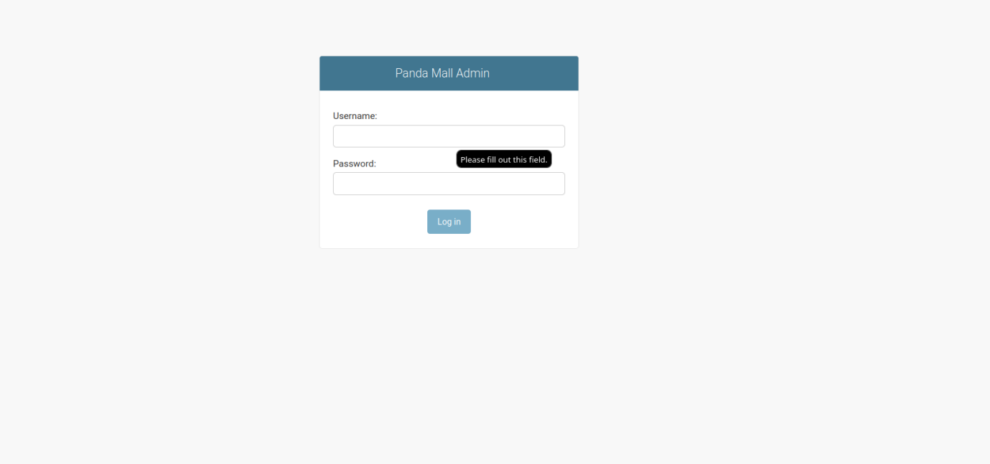

Figure 2: Login Screen

Admin panel login screen.

This GUI shows the “Manage Products” section of the admin panel.

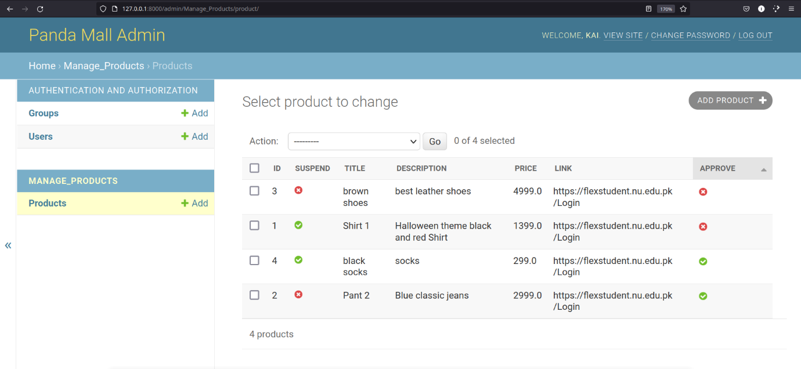

Figure 3: Manage Products

Manage Products Section

This GUI shows the edit page where an admin can approve, reject or suspend a product.

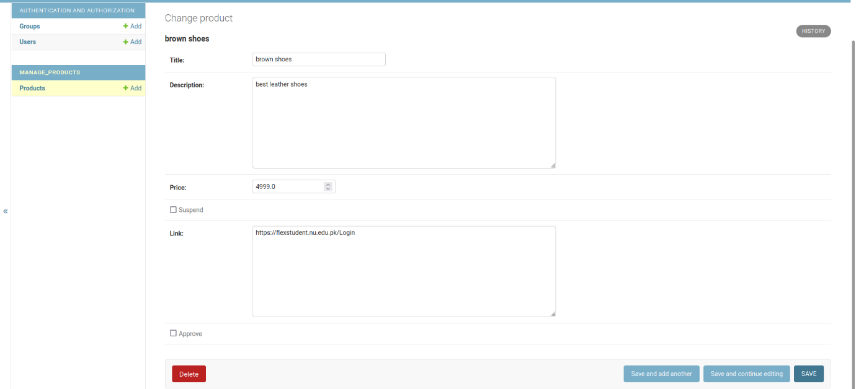

Figure 4: Update product page

Update product page at admin panel

### Store GUI

This GUI shows the home page of a store.

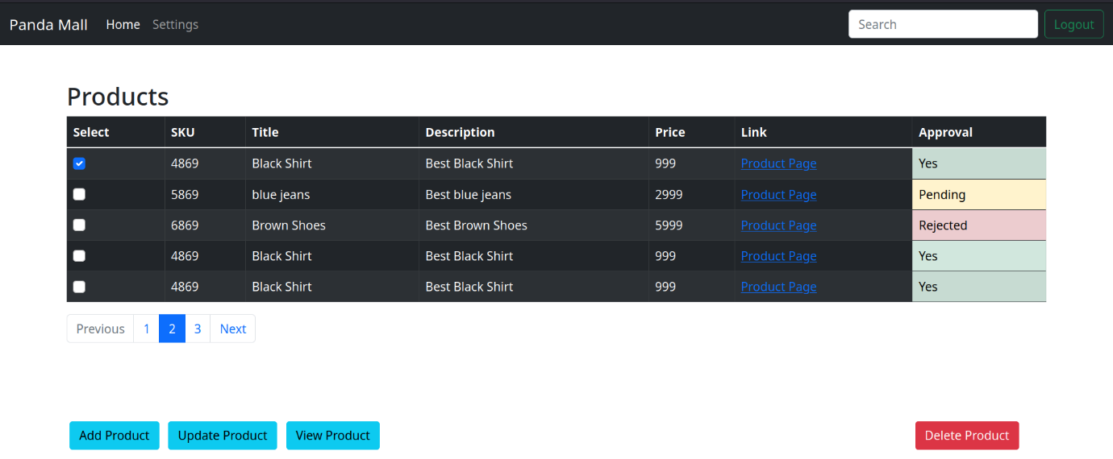

Figure 5: Store home page

Store home page

This GUI shows the delete pop up window before a product is deleted.

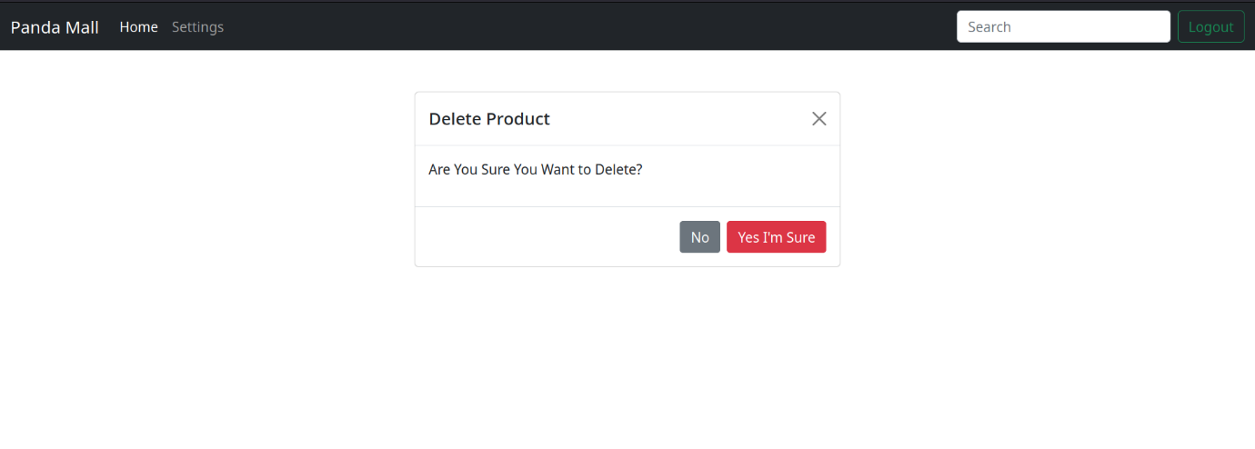

Figure 6: Pop up window

Pop up window when delete button clicked

This GUI shows the details of a product and allows to edit the product. This GUI is same for add products and update as the latter has prefilled values.

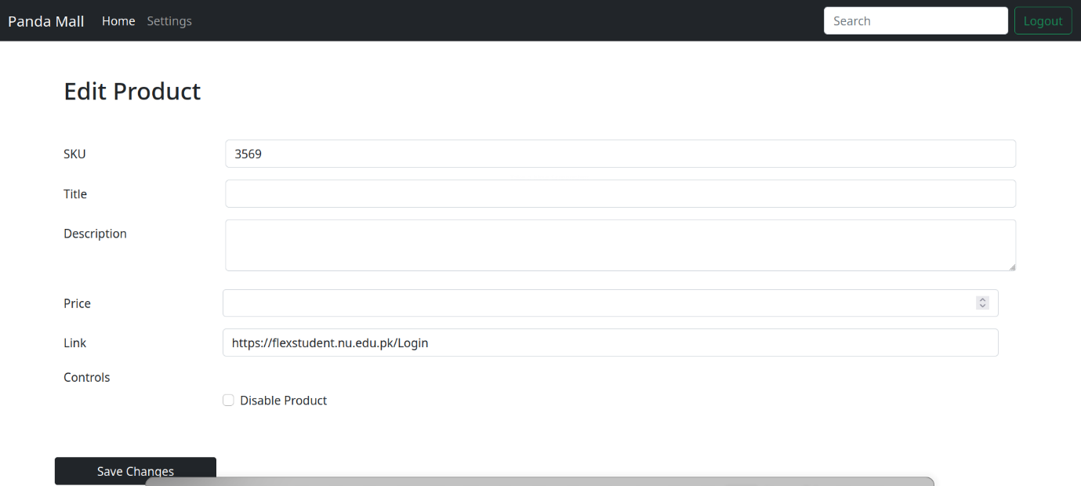

Figure 7: Edit product

Edit product page for store type user

### Login GUI

This GUI shows the login page of our website.

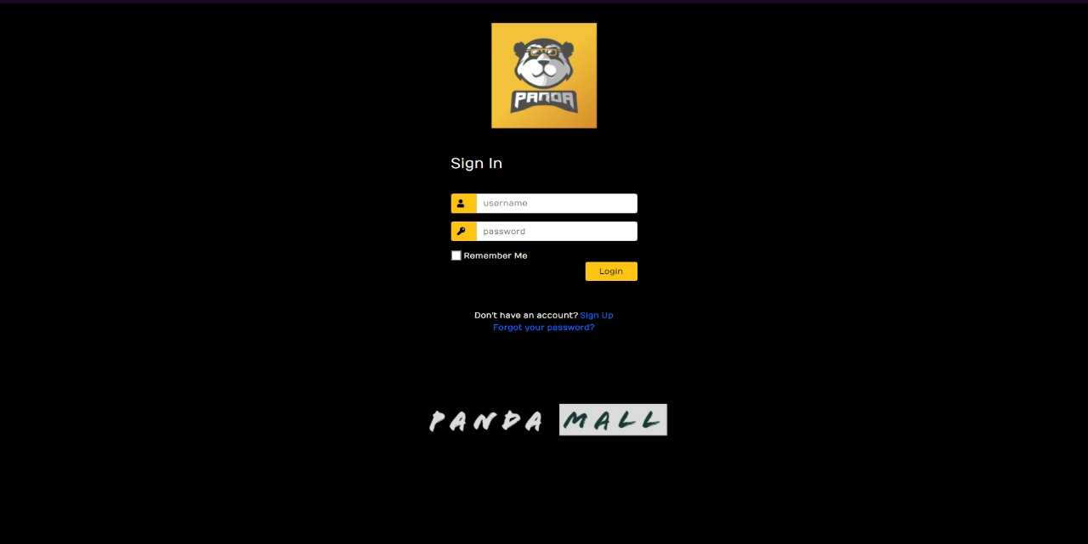

Figure 8: Login page

Website’s login page

### Sign Up GUI

This GUI shows the Sign-Up page of our website.

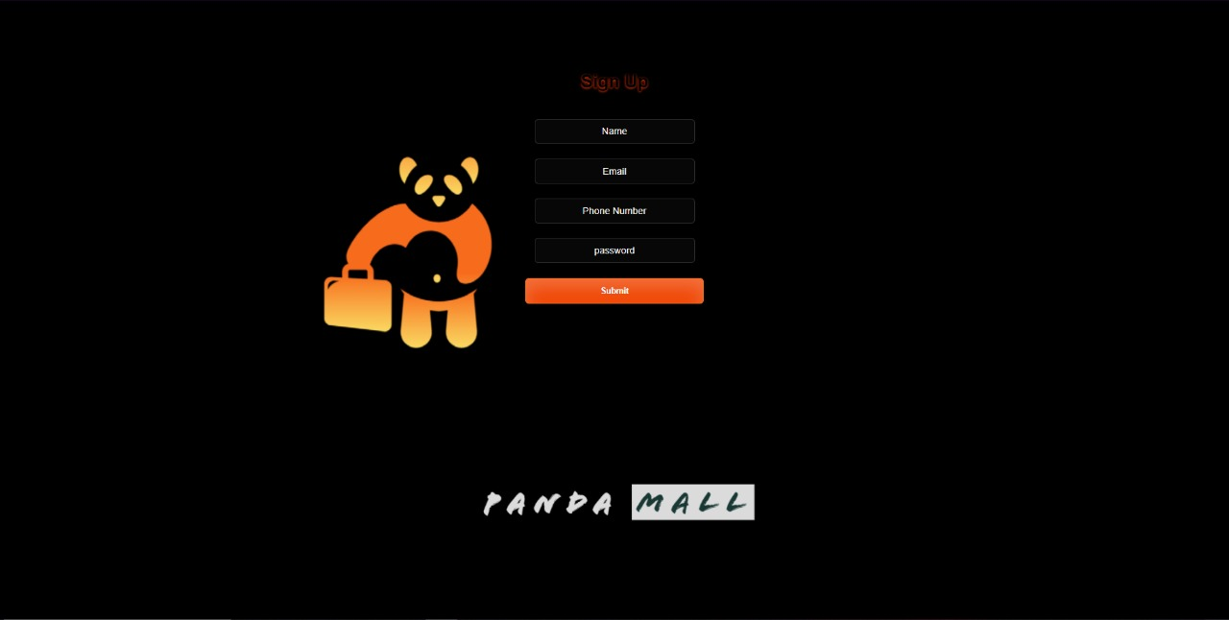

Figure 9: Sign Up page

Website’s sign-up page

### User/Client Pages GUI

This GUI shows the favourites page of our website. All of user’s favourites products are placed on this page.

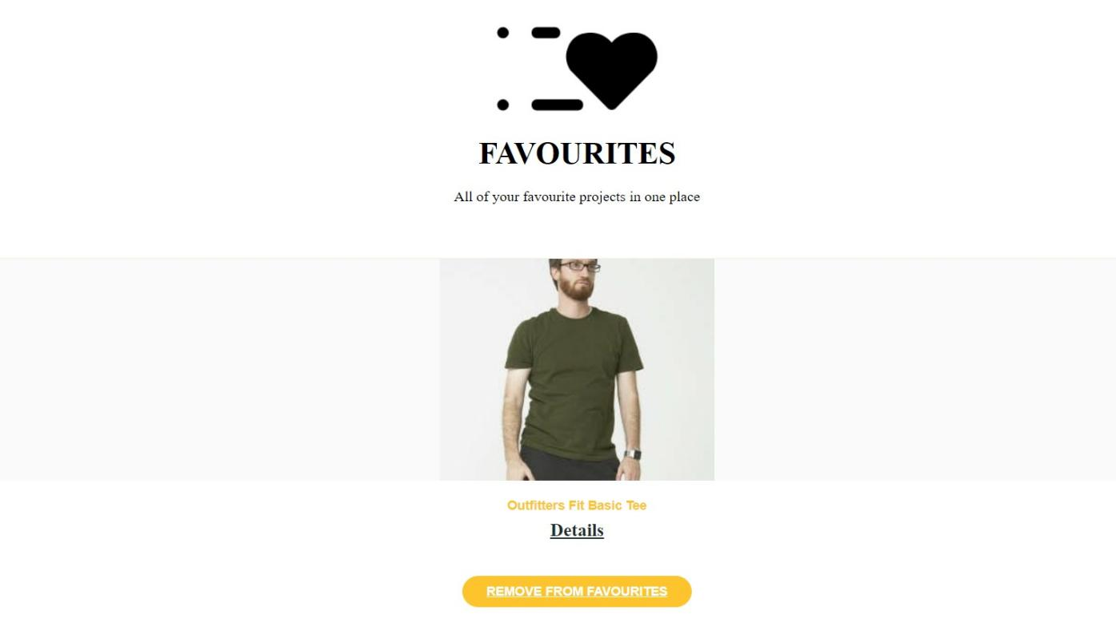

Figure 10: Favorite’s page

Website’s favourites page

This GUI shows the product details pop up window of our website. From this page we can buy a product along with viewing its details. Moreover, we can give feedback of a product that we have bought.

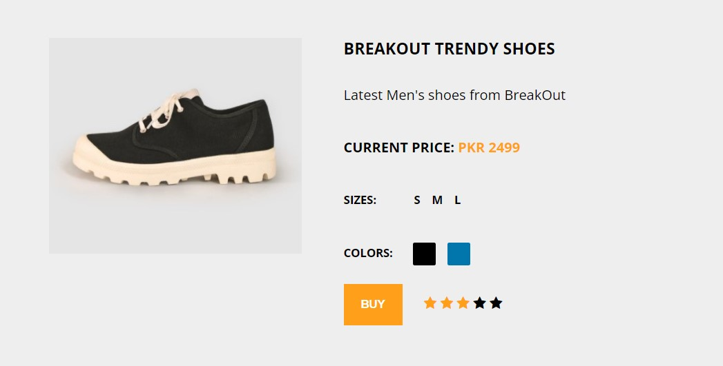

Figure 11: Product Details page

Products Detail page

This GUI shows the Home page for the user where user can see products to buy from. User can add product to favorite’s list, can see the details of the product. Also, user can use filters to filter out specific product. User can also search a specific product and also can see his profile.

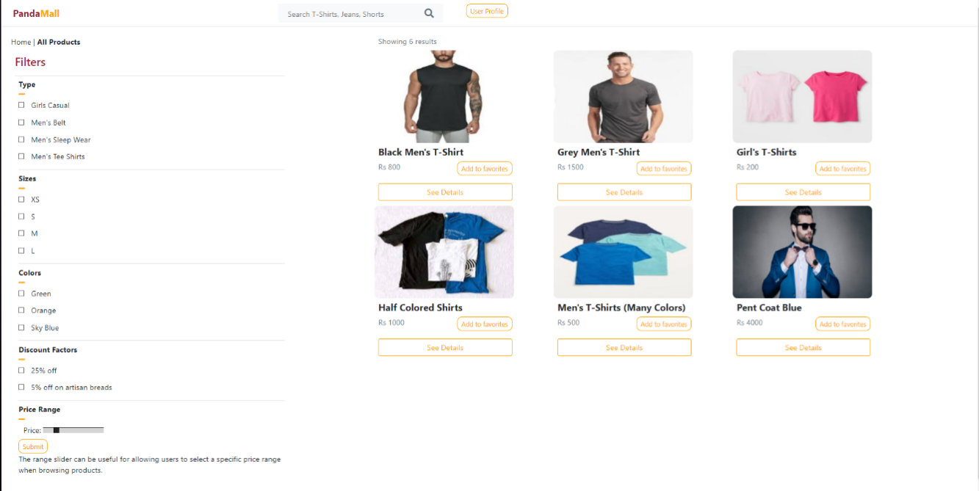

Figure 12: Home Page

Home page containing products

This GUI shows the User’s profile where he can see his information. User can access feedback page and favorite’s page from here as well. Also user can sign out from here as well.

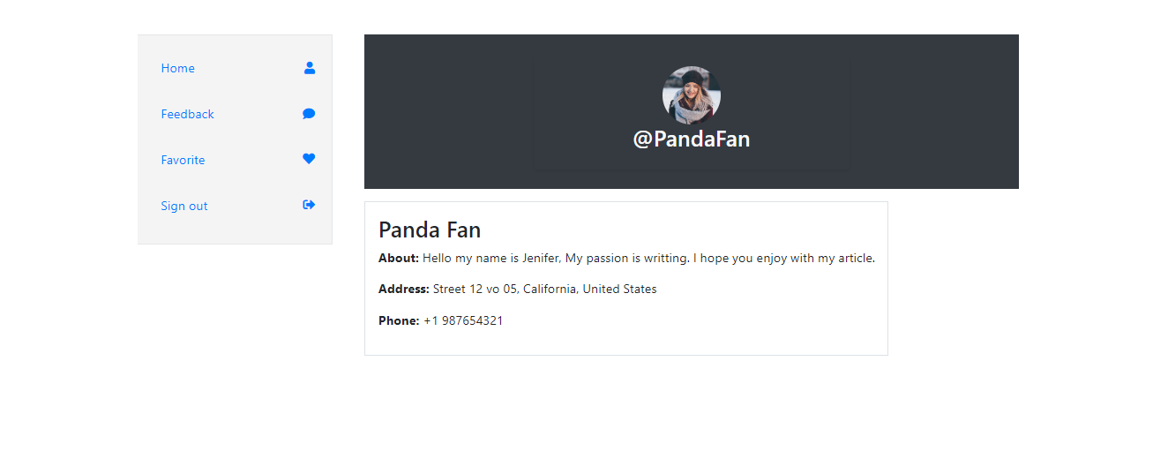

Figure 13: Profile page

Profile containing user information

## Database Design

### ER Diagram

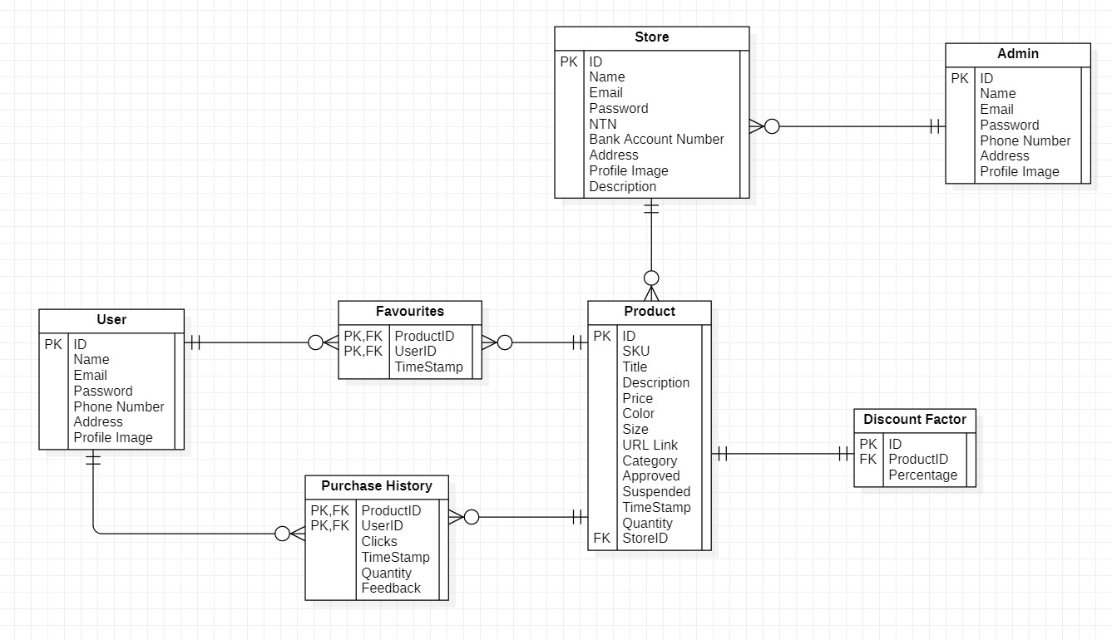

Figure 14: ER Diagram

This shows the ER Diagram of our system database

### Data Dictionary

#### User

Table 1: User Data Dictionary

This is the data dictionary of user.

|  |  |  |
| --- | --- | --- |
| **Fields** | **Data Types** | **Example** |
| ID | Long | 1992 |
| Name | String | Ben White |
| Email | String | [benwhite@gmail.com](mailto:benwhite@gmail.com) |
| Password | String | ArsenalFC |
| Phone Number | String | 0321-xxxxxxx |
| Address | String | 852-B Milaad St, Block B Faisal Town, Lahore, Punjab 54770 |
| Profile Image | String | myWebsite.com/proiflepic.jpg |

#### Favourite

Table 2: Favourites Data Dictionary

This is the data dictionary of favourites.

|  |  |  |
| --- | --- | --- |
| **Fields** | **Data Types** | **Examples** |
| ProductID  (FK from ID of Product table) | Long | 221 |
| UserID  (FK from ID of Product table) | Long | 1919 |
| TimeStamp | datetime | 2016-12-21 00:00:00.000 |

#### Product

Table 3: Product Data Dictionary

This is the data dictionary of Product.

|  |  |  |
| --- | --- | --- |
| **Fields** | **Data Types** | **Examples** |
| ID | Long | 23 |
| SKU | String | K91919 |
| Title | String | Shorts |
| Description | String | Any description |
| Price | Float | 99.99 |
| Color | String | Red |
| Size | String | [Medium](https://somename.com/) |
| URL | String | My-website.com/product=10 |
| Category | String | Men |
| Approved | Boolean | True |
| Suspended | Boolean | False |
| TimeStamp | DateTime | 2016-12-21 00:00:00.000 |
| Quantity | Int | 10 |
| StoreID (FK) | Long | 101 |

#### 

#### Purchase History

Table 4: Purchase History Data Dictionary

This is the data dictionary of Purchase History.

|  |  |  |
| --- | --- | --- |
| **Field** | **Data Types** | **Examples** |
| ProductID (PK, FK) | Long | 23 |
| UserID (PK, FK) | Long | 12 |
| Clicks | Int | 20 |
| TimeStamp | DateTime | 2016-12-21 00:00:00.000 |
| Quantity | Int | 15 |
| Feedback | String | Great Product |

#### Store

Table 5: Store Data Dictionary

This is the data dictionary of Store.

|  |  |  |
| --- | --- | --- |
| **Field** | **Data Types** | **Examples** |
| ID | Long | 7 |
| Name | String | Tayyab |
| Email | String | [tayyab@gmail.com](mailto:tayyab@gmail.com) |
| Password | String | Qwerty1234 |
| NTN | String | 231242134-9 |
| Bank Account Number | String | HQM21HJ819 |
| Address | String | 134 A Muslim Town |
| Profile Image | String | myWebsite.com/proiflepic.jpg |
| Description | String | Detailed Info |

#### Admin

Table 6: Admin Data Dictionary

This is the data dictionary of Admin.

|  |  |  |
| --- | --- | --- |
| **Fields** | **Data Types** | **Examples** |
| ID | Long | 23 |
| Name | String | Tayyab |
| Email | String | [tayyab@gmail.com](mailto:tayyab@gmail.com) |
| Password | String | Tayyabqwerty |
| Phone Number | String | 03401913211 |
| Profile Image | String | myWebsite.com/proiflepic.jpg |

#### Discount Factor

Table 7: Discount Factor Data Dictionary

This is the data dictionary of Discount.

|  |  |  |
| --- | --- | --- |
| **Field** | **Data Types** | **Examples** |
| ID | Long | 3 |
| ProductID (FK) | Long | 29 |
| Percentage | Float | 70.1 |

## System Requirements

### Hardware Requirements

* A IOT device that supports a browser.
* Internet connection should have at least 1Mbps.
* A web server to host our website.

### Software Requirements

* Web browser in the system.

## Design Considerations

Before attempting to build a complete design solution, this section explains many of the challenges that must be addressed or overcome.



### Assumptions and Dependencies

Following are the assumptions or dependencies regarding the software and its use. These may concern such issues as:

* User has a desktop with 2GB RAM and 64-bit Operating system.
* Users have JS enabled browsers installed.
* Users must have internet connection.
* User is familiar with understanding of basic e-commerce.

### General Constraints

Following are the global limitations or constraints that have a significant impact on the design of the system's software:

#### Hardware or software environment

* We are designing a web application, so targeted systems should have JS supported browsers such as Google Chrome or Mozilla Firefox.
* In the case of hardware, web application requires 2 GB RAM, 64-bit OS.

#### End-user environment

* Users can utilize the online application with high-speed internet and a browser that supports the idea of web caching and cookies to save data for future use, as specified in the software requirements.

#### Availability or volatility of resources

* High speed and uninterrupted internet is required for better performance.

#### Interoperability requirements

* Client and server have to share and store data using common standards.

#### Interface/protocol requirements

* Http protocol will be used for communication between client and server.
* Interface will be implemented using react framework and running on browsers which are mentioned in software requirement.

#### Data repository and distribution requirements

* For web application data storage and retrieval, online cloud-based databases will be employed. It can only be changed by the administrator.

#### Security requirements (or other such regulations)

* System will be performing actions using secure protocols, secure the personal information of users by using the CSRF tokens for forms and data transfer.
* System will perform authentication and authorization.

#### Memory and other capacity limitations

* System requires CPU, Memory, I/O capacity, Bandwidth and cache space for better performance.

#### Verification and validation requirements (testing)

* The system will allow those users who have correct login credentials to conduct actions.

#### Language Constraints

* This system is only useful to those who are familiar with English language.

## Development Methods

We chose the agile model, specifically the scrum method [2]. When it comes to development, the main justification for using the scrum model is its productivity and quality. In addition, this paradigm aids in the rapid development of our software. In addition, we held daily meetings with each other to keep track of our development and performance. Another advantage that drew us to this approach over others was its flexibility to adapt to changing requirements as we went along. We used the Scrum paradigm to break tasks into sprints, which simplified our job. Following were the steps in each sprint:

1. Planning

2. Implementation

3. Review

4. Retrospect

We initially examined two methods: the agile model, which we ultimately chose, and the prototype model. The following are the main reasons for not implementing the prototype model:

1. Poor documentation because of changing system requirements.

2. Incomplete problem analysis.

3. Increases the complexity of the system.

## Class diagram

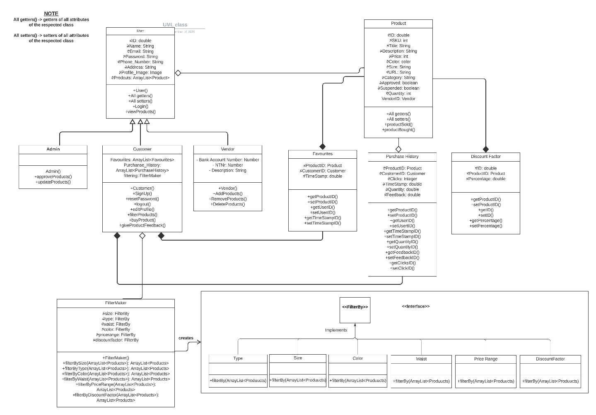

Figure 15: Class Diagram

Diagram for high level system architecture.

## Sequence diagram

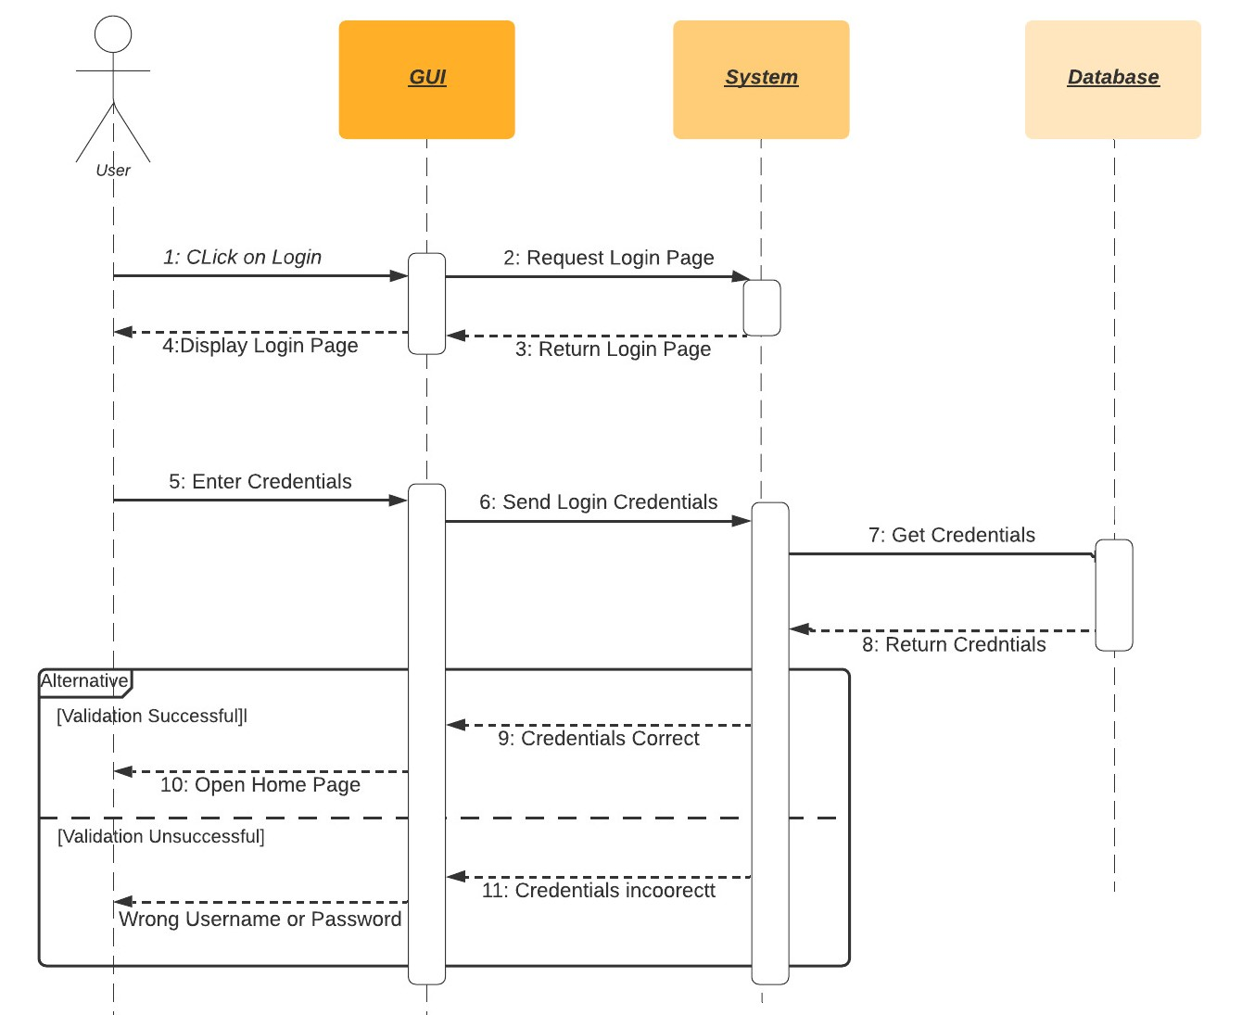

Figure 16: Login Account

This is the sequence diagram of Login Account for Users

.

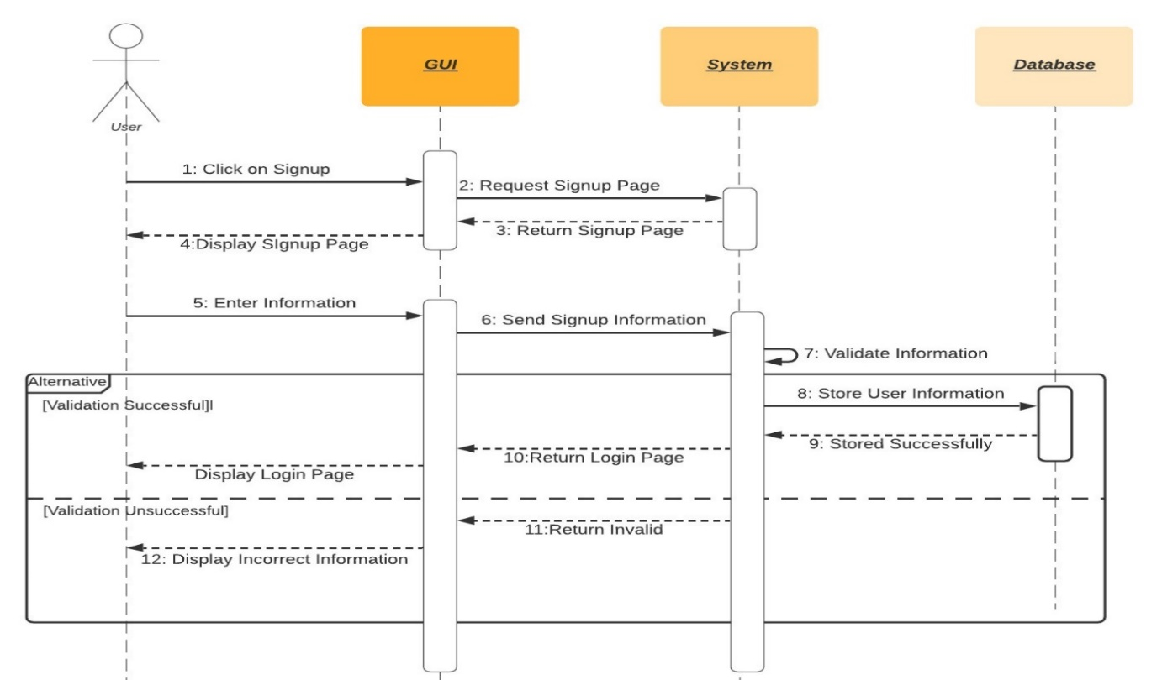

Figure 17: Create Account/Signup

This is the sequence diagram of Signup for Users.

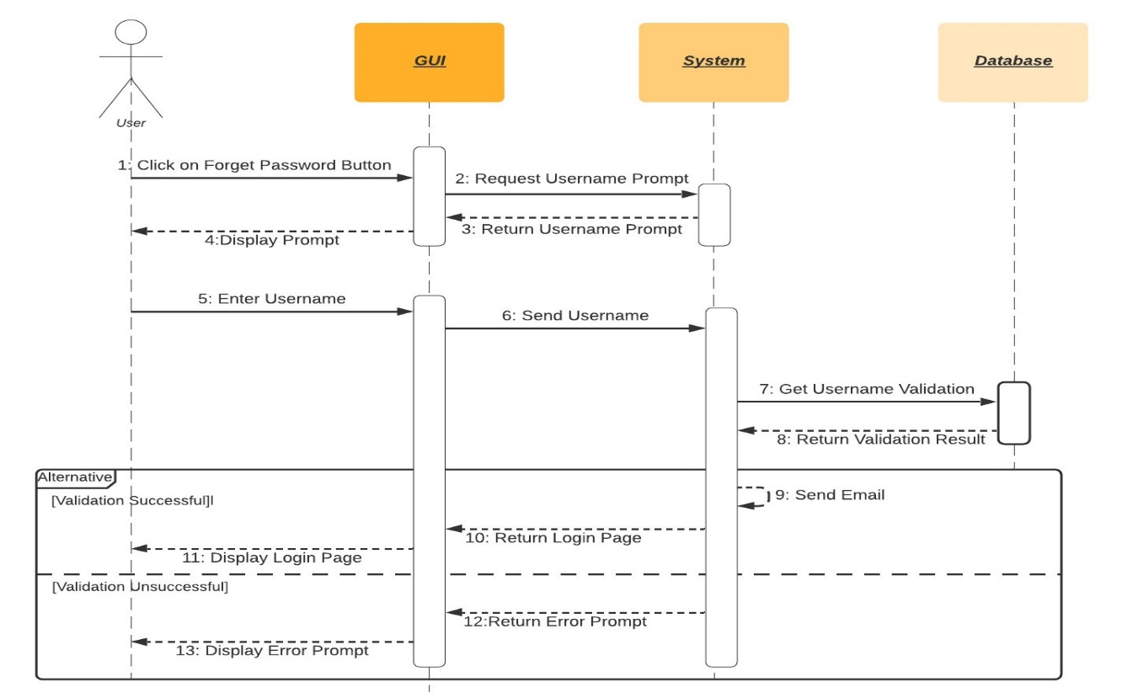

Figure 18: Reset/Forget Password

This is the sequence diagram of Reset/Forget Password for Users.

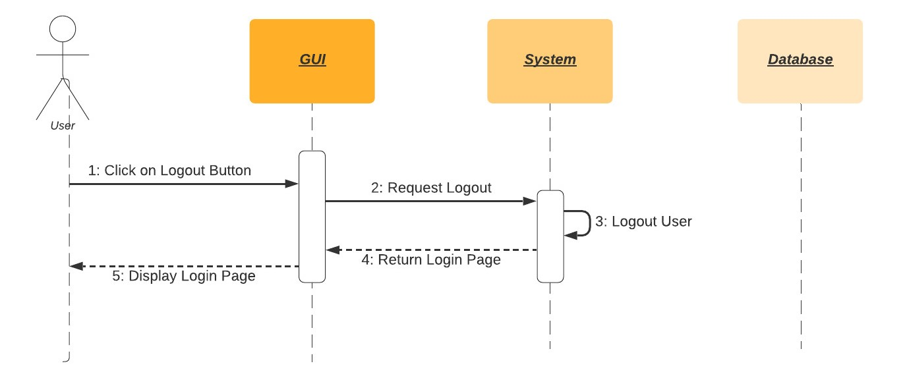

Figure 19: Logout

This is the sequence diagram of Logout Procedure for Users.

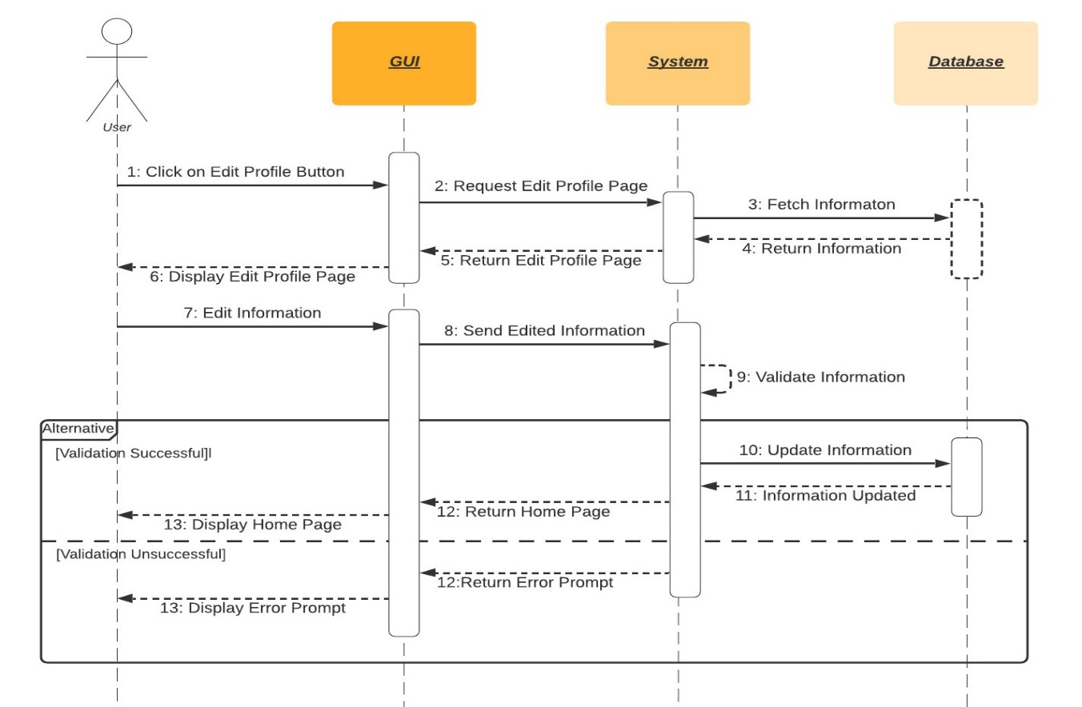

Figure 20: Edit Profile

This is the sequence diagram of Edit Profile for Users

.

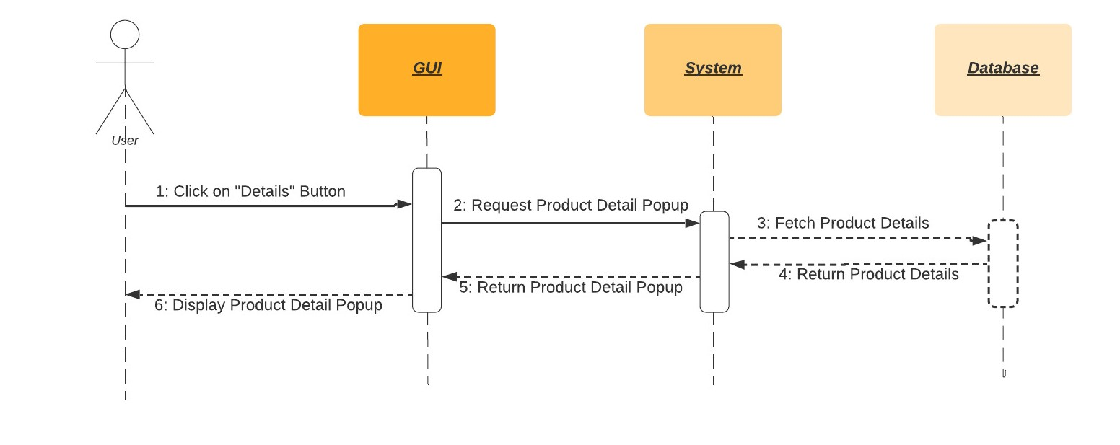

Figure 21: View Product Details

This is the sequence diagram of View Product Details.

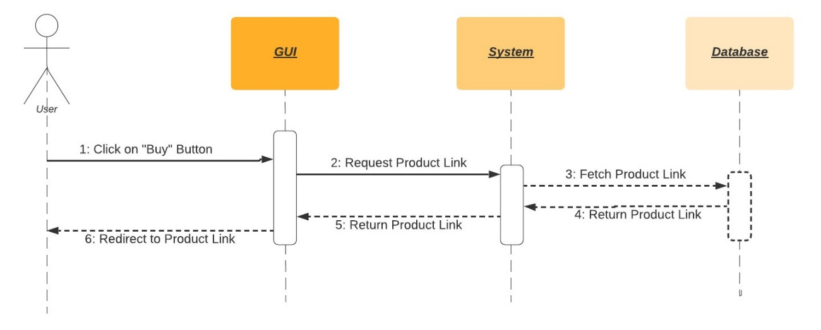

Figure 22: Buy Product

This is the sequence diagram of Buy a Product Procedure.

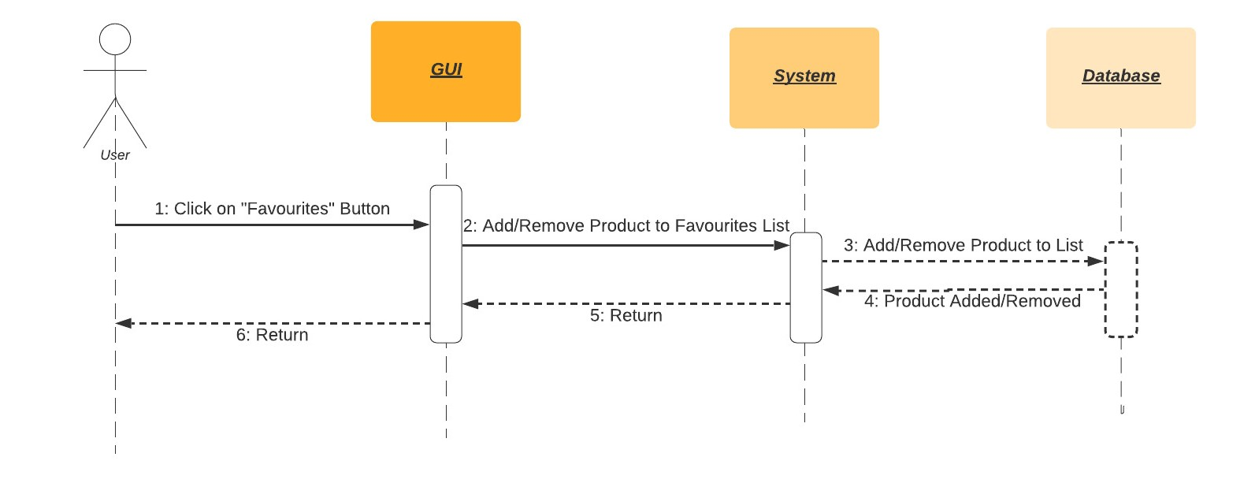

Figure 23: Add/Remove favorites

This is the sequence diagram of Removing and Adding Products from Favourites list

.

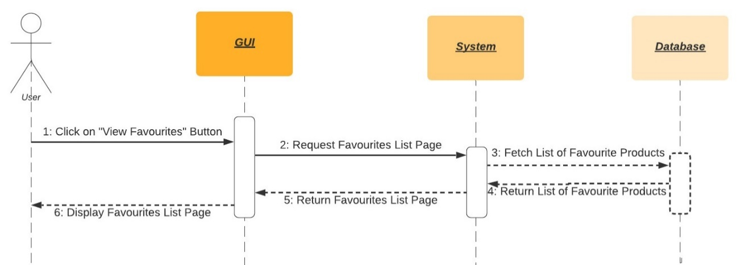

Figure 24: View Favorites List

This is the sequence diagram of Viewing Favourites List.

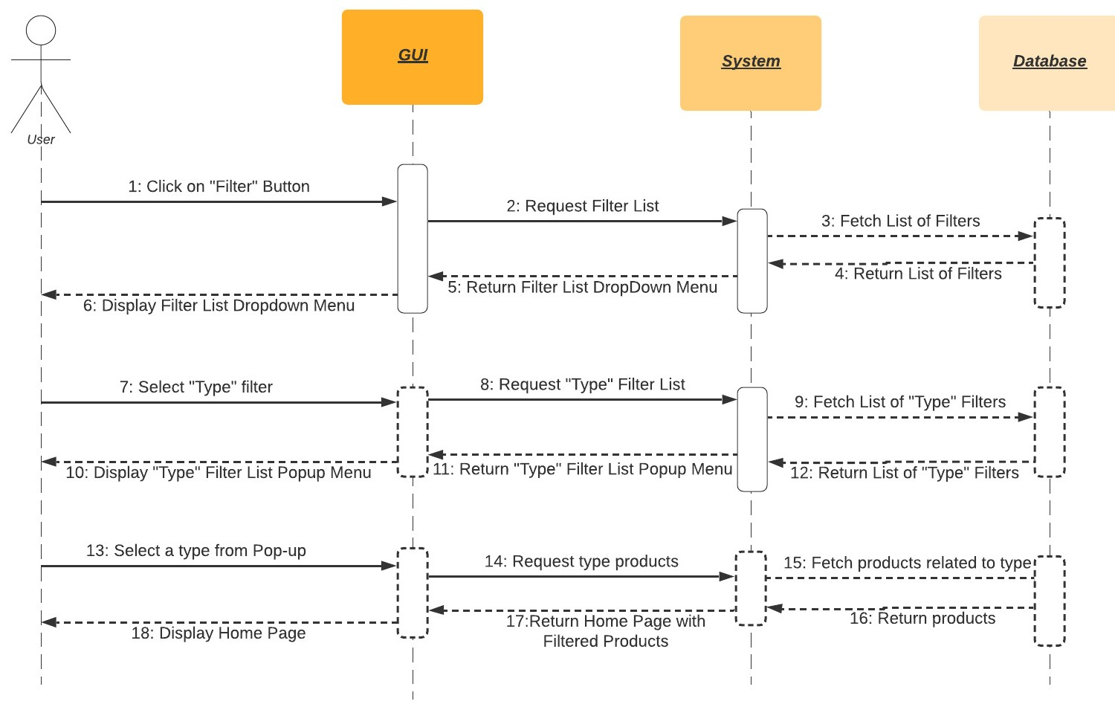

Figure 25: Filter by Type

This is the sequence diagram of filtering products by their “Type”.

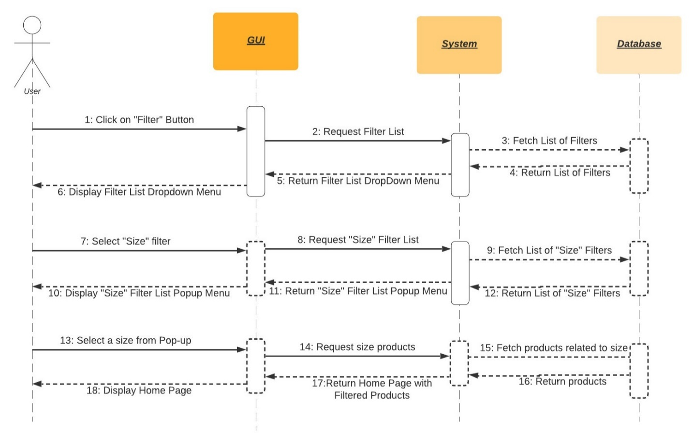

Figure 26: Filter by Size

This is the sequence diagram of filtering products by their “Size”.

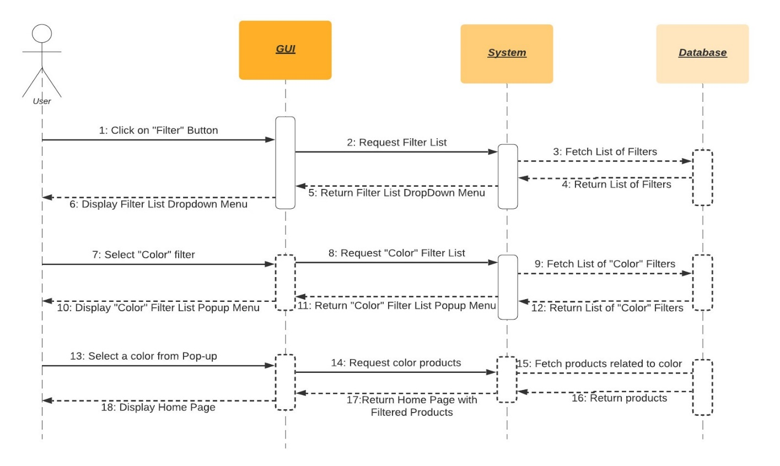

Figure 27: Filter by Color

This is the sequence diagram of filtering products by their “Colour”.

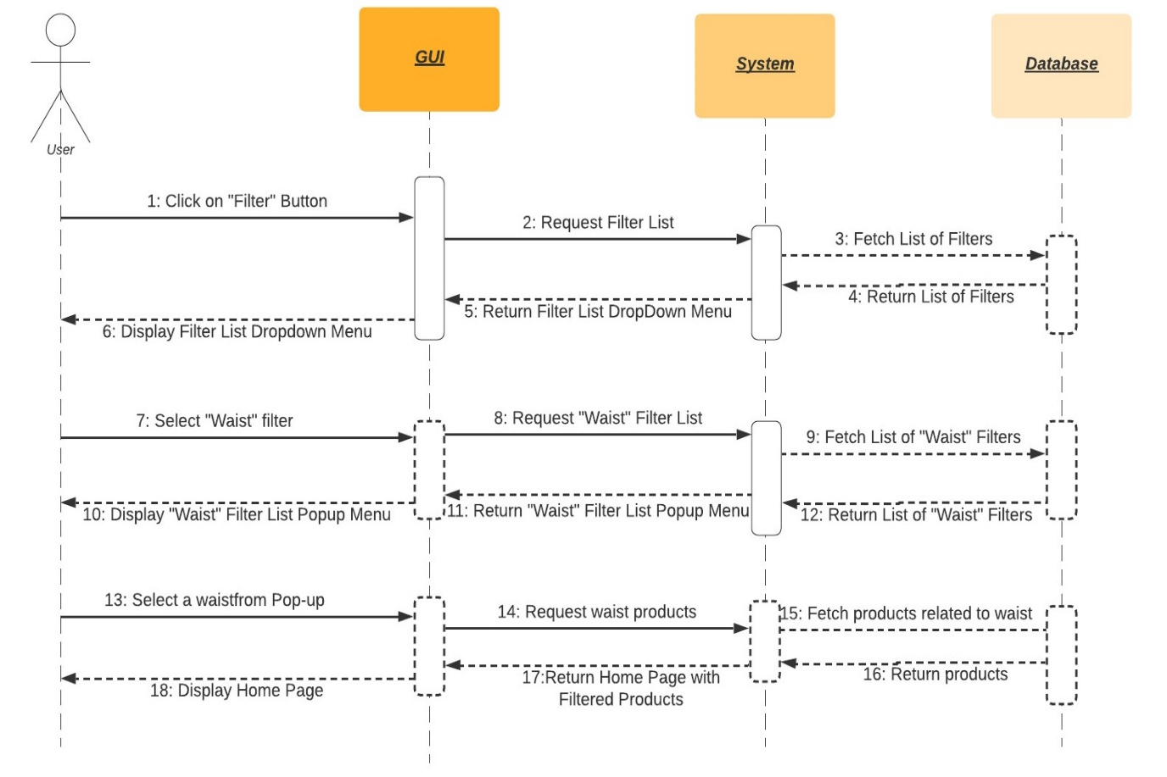

Figure 28: Filter by Waist

This is the sequence diagram of filtering products by their “Waist”.

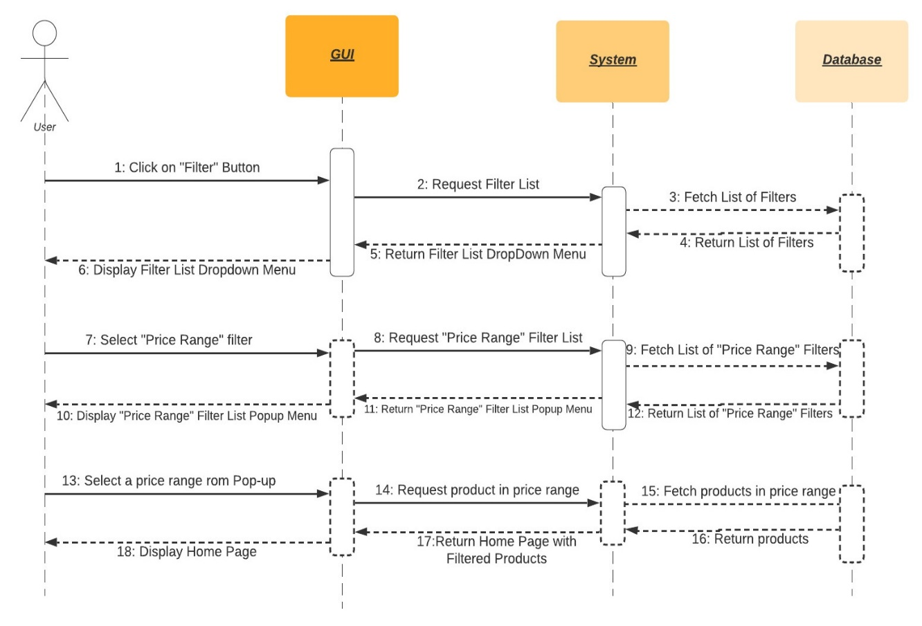

Figure 29: Filter by Price Range

This is the sequence diagram of filtering products by their “Price Range”.

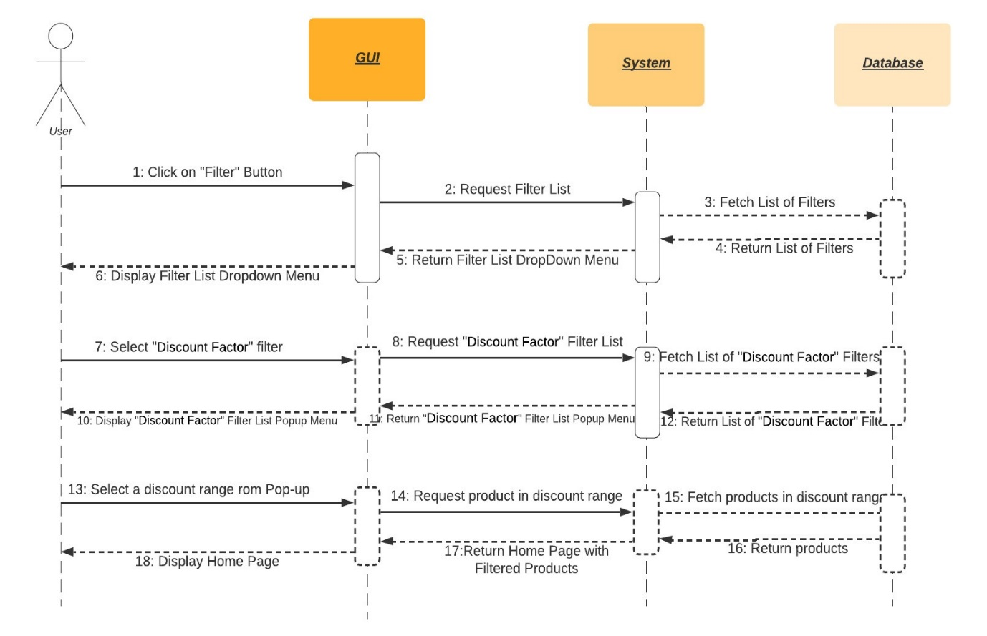

Figure 30: Filter by Discount Factor

This is the sequence diagram of filtering products by their “Discount Factor”.

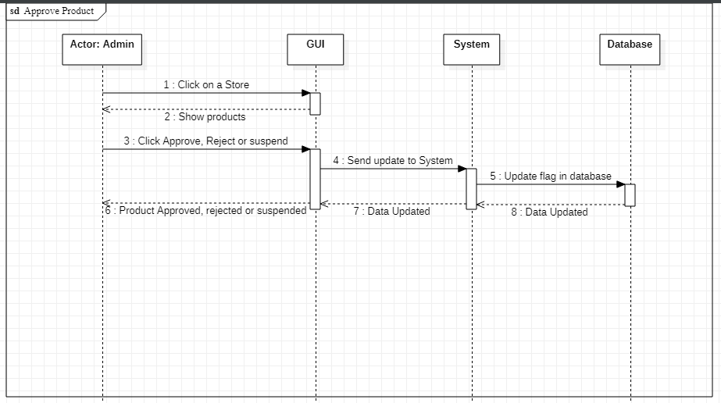

Figure 31: Product Approval

This is the sequence diagram of product approval, rejection or suspension.

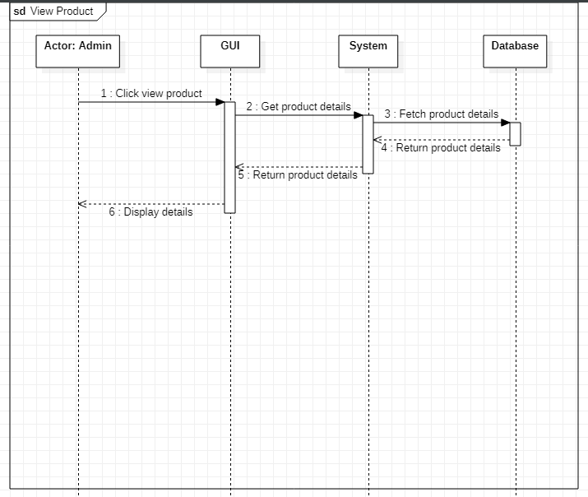

Figure 32: View Product

This is the sequence diagram of admin view product details.

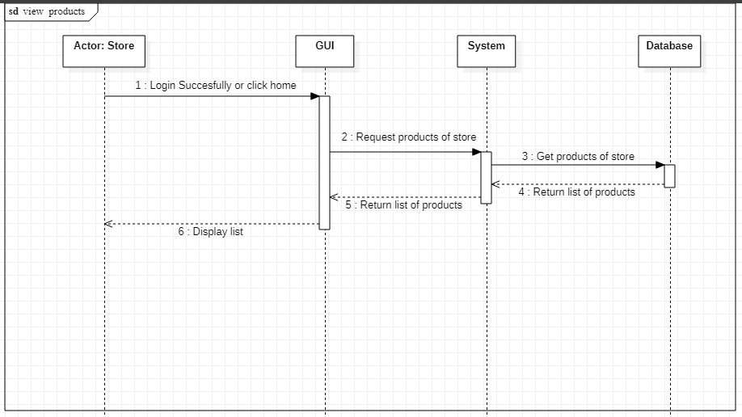

Figure 33: Home Page

This is the sequence diagram of store home page with product list.

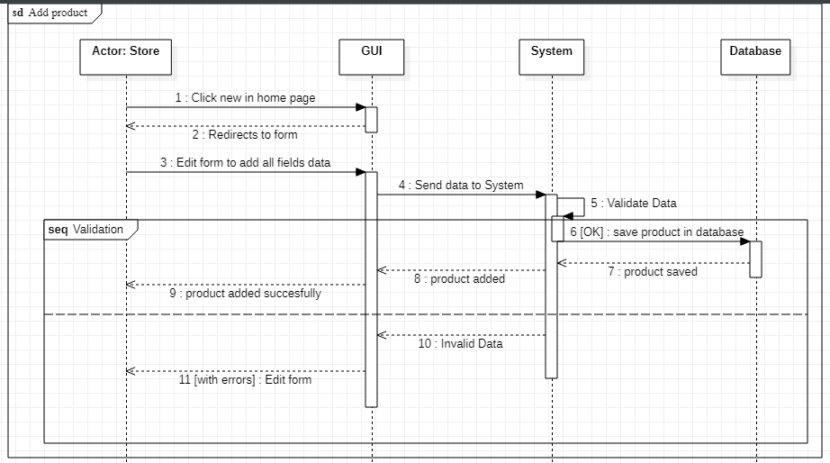

Figure 34: Add Product

This is the sequence diagram of store adding a product.

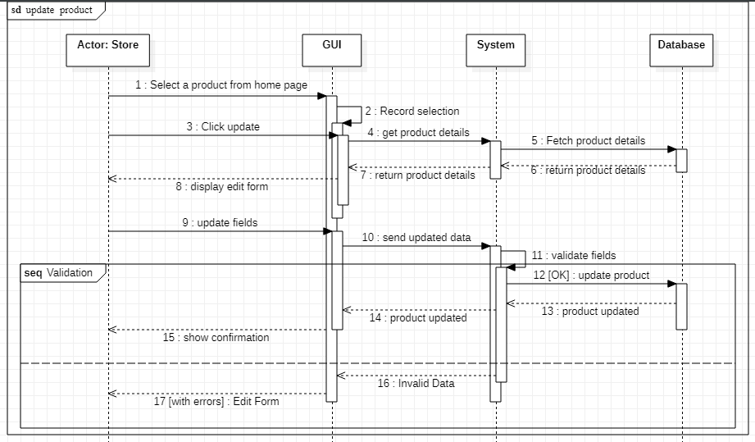

Figure 35: Update product

This is the sequence diagram of store updating a product.

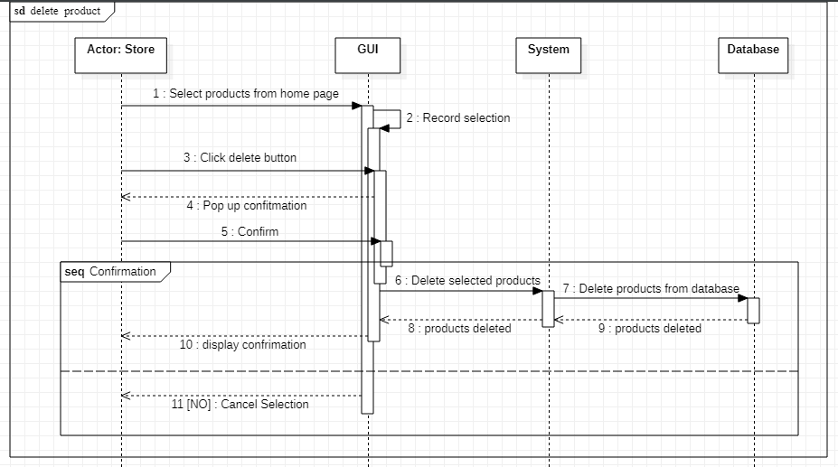

Figure 36: Delete Product

This is the sequence diagram of store deleting a product.

## Policies and Tactics

### Product to use

We will be using the latest version of python along with the Collaborative Filtering library. Moreover, we will use real-time cloud based databased named MongoDB. For running our Python code, we will use PyCharm.

### Coding guidelines and conventions

To make our code more structural and legible, all standard coding rules will be followed, including properly commented code and the use of OOP ideas while coding. Furthermore, as previously indicated, we will use Ben Schneiderman's 8 golden standards of UI design when creating our UI.

### Testing the software

Acceptance testing, unit testing, functional testing, performance testing, stress testing, and usability testing are some of the testing methodologies we studied in software engineering.

Furthermore, we will collect testing data from our university students and run it through our algorithm, after which we will compare the output of our algorithm to the testing data to ensure that our system is accurate enough.

### Maintaining the software

After our fyp is finished we will release improved versions of our software with added feature to assist the users. Moreover, we will fix any possible future faults in our system.

### Protocol

Http protocol will be used for communication between client and server. Interface will be implemented using react framework and running on browsers which are mentioned in software requirement. As we are using MongoDB, we will be storing data in JSON format hence data will flow over the network in JSON format.

### Accessing the application

The web application would be hosted on cloud accessible with a URL link. Users having an account can access the application by going through the authentication procedure. Incase a user doesn’t have an account he can signup to make a new account. For vendors they must register their store on our website to add their products.

### Choice of algorithm

We will use brute force approach along with different variants of collaborative filtering. We will choose the algorithm that gives us the best results.

### Web Scrapping

We will scrap popular clothing brands website to retrieve their products by using a web scraping tool known as beautiful soup.

# Implementation and Test Cases

This chapter provides the implementation details of our prototype.

## Implementation

Initially we have scraped data from websites of few popular clothing brands of Pakistan using Beautiful Soup which is a library of Python. After that we have cleaned the data and after that we worked on extracting the features from our data set that will help us to optimize the accuracy of our prototype. We ran our data on different types of Collaborative filtering algorithms alongside brute force approach in order to test the accuracy of these algorithm.

### Beautiful Soup

It is a Python library that is used to scrape HTML web pages in order to extract data from them and save it in csv files. We are using Beautiful Soup to extract products from websites of different clothing brands.

### Brute Force

We tried to recommend products using brute force method. For example, we stored a count for each product bought and recommended the product that was the bought the most.

### Collaborative Filtering

This is the most popular algorithm when it comes to recommendation systems. It basically recommends user certain products based on the behavior of many users. We implemented both types of Collaborative Filtering;

* User-based Collaborative Filtering: This technique basically filters users based on their similar buying habits and groups them together.
* Item-based Collaborative Filtering: On the other hand, this technique filters items based of similarities among them and recommends them to users based on that.

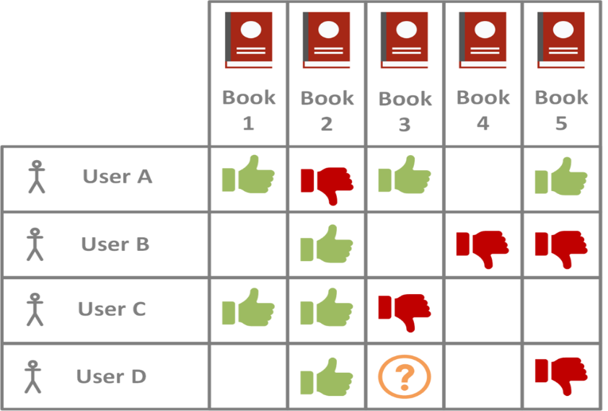

Figure 37: Collaborative Filtering

This is the sequence diagram explaining the working of Collaborative Filtering Algorithm

# Conclusion

First, we had to decide what sorts of products we wanted to recommend to consumers. Then there's deciding which features to put on a website and which jobs to add to our database. For each position, we determined the use cases and functionalities that would be offered. We'll next incorporate this into our system design and develop ER and DB diagrams for each role.

We ran into a few issues while scraping different companies' webpages due to the varying website versions and structing customizations. Furthermore, these scraping concerns will exist in the future because brands may change their websites at any time, necessitating the frequent updating of our data and scraping code.

Following February, we expect to be able to complete our FYP 2 development phase in a month or two. We'll work to increase the accuracy of our suggestion algorithm and isolate those specific factors that can help us improve our results. In addition, we will continue to test our project and enhance our website during the FYP 2 phase. We plan to complete this as soon as possible and, if time permits, add further features to our product, such as a shopping cart and payment methods.

# References

1. Reutskaja, E., Lindner, A., Nagel, R. et al. “Choice overload reduces neural signatures of choice set value in dorsal striatum and anterior cingulate cortex.” *Nature Human Behavior,* vol 2, no. 925–935, Oct, 2018. [Online serial]. Available: <https://doi.org/10.1038/s41562-018-0440-2>[Accessed Sept. 30, 2021]
2. Y. Hu, X. Yi, and L. S. Davis, “Collaborative fashion recommendation: A functional tensor factorization approach,” in Proceedings of the 23rd Annual ACM Conference on Multimedia Conference, 2015.
3. E. A. Nogueira, E. V. De Melo, E. R. De Faria, and D. Guliato, “IKB-MS: A collaborative filtering approach associated with human visual attention for clothing recommendation,” in Proceedings of the 21st Brazilian Symposium on Multimedia and the Web, WebMedia 2015, pp. 149-156, October 2015.
4. N. Landia, “Building Fashion Recommendation System”, *dressipi.com*, Apr. 19, 2018. [Online]. Available: <https://dressipi.com/blog/building-fashionrecommendation-systems/>. [Accessed Sept. 27, 2021].
5. David Chong, “Deep Dive into Netflix’s Recommender System”, *towardsdatascience.com*, Apr. 30, 2020. [Online]. Available: <https://towardsdatascience.com/deep-diveintonetflixsrecommendersystem341806ae3b48> [Accessed Nov. 2, 2021]